

MobiVue PMMS

Ajanta Pharma Ltd.

Functional Specification Document (WMS)

This document includes the functional and non- functional requirements for specification of the application designed for Ajanta Pharma.

BAR CODE INDIA, 145 Udyog Vihar Phase 1, Gurugram, Haryana-122016, PH: 0124 4337555 1

Prepared By: Leena
Version Number: 1.0
BAR CODE INDIA, 691 UDYOG VIHAR PHASE V, GURUGRAM, HARYANA - 122016, Ph.: 0124 4337555

Notice
This document contains information, which is the proprietary property of Bar Code India. This document is received in confidence and its contents cannot be disclosed or copied without the prior written consent of Bar Code India.
Nothing in this document constitutes a guaranty, warranty, or license, express or implied. Bar Code India disclaims all liability for all such guaranties, warranties, and licenses, including but not limited to: Fitness for a particular purpose; merchantability; not infringement of intellectual property or other rights of any third party or of Bar Code India; indemnity; and all others. The reader is advised that third parties can have intellectual property rights that can be relevant to this document and the technologies discussed herein and are advised to seek the advice of competent legal counsel, without obligation of Bar Code India.
Bar Code India retains the right to make changes to this document at any time, without notice. Bar Code India makes no warranty for the use of this document and assumes no responsibility for any errors that can appear in the document nor does it make a commitment to update the information contained herein.

COPYRIGHT
Copyright © BCI 2023. All rights reserved.
TRADEMARKS
*Other product and corporate names may be trademarks of other companies and are used only for explanation and to the owners' benefit, without intent to infringe.

Revision History
Revision Number | Date | Prepared By | Reviewed By | Comment
00 | 22.05.2023 | Leena Patil | Sailendra Das | Functional & Design Specification document

Table of Contents
Notice 2
Revision History 3
1 Protocol Approval 8
2 Functional Requirements 9
2.1 System Architecture 9
2.2 Object Model Workflow 10
2.2.1 Pharmision Code Data flow 10
2.2.3 Communication Flow ( SAP -BCI) 11
2.2.4 API Access Token 12
2.3 Hardware and Software Details 13
2.3.1 Hardware Details 13
2.3.2 Software Details 13
2.4 Interfaces 14
2.4.1 Architecture 14
2.4.2 Component Descriptions 15
2.5 WMS Application Flow 16
2.6 Flow Diagram for the Inward Process 17
2.7 Flow Diagram for Sampling Process 18
2.8 Flow Diagram for Dispensing process 19
2.9 Electronic Log System 20
2.9.1 Error Logs 20
2.9.2 Audit Logs 20
2.10 Error, Alarm and Warning Messages 20
2.11 Security 22
2.11.1 Authentication 22
Authorization 23
Auditing 23
2.12 Plant Registration Details 23
3 Application Modules 24
3.1 User Management` 24
3.1.1 User Master 26
3.1.2 Role Management/ Permission 27
3.1.3 Password Management 28
3.2 Masters 29
3.2.1 Plant Master 29
3.2.2 Department Master 30
3.2.3 Area Master 31
3.2.4 Cubicle Master 32
3.2.5 Bin Locations Master 33
3.2.6 Equipment Master 34
3.2.7 Handling Unit Master 36
3.2.8 Gates Master 37
3.2.9 Checklist Type Master 38
3.2.10 Checklists Master 39
3.2.11 Weighing Balance Master 40
3.2.12 Standard Weight Boxes Master 44
3.2.13 Standard Weight Master 45
3.2.14 Devices Master 46
3.2.15 Activity Master 47
3.2.16 Transporter List Master 48
3.2.17 Add SAP Storage Location Master 49
3.3 Inward 50
3.3.1 Gate Entry 50
3.3.2 Vehicle Inspection 52
3.3.3 Material Inspection 54
3.3.4 Weight Quantity/Verification 56
3.3.5 GRN Posting 58
3.3.6 Material Label Printing 60
3.3.7 Palletization 61
3.3.8 Put Away 62
3.3.9 Bin To Bin Transfer 64
3.3.10 GRN Cancellation 65
3.3.11 GRN RePosting 66
3.4 Weighing Calibration 68
3.5 Sampling 71
3.5.1 Cubicle Assignment 71
3.5.2 Cubicle Cleaning 73
3.5.3 Equipment Cleaning 76
3.5.4 Equipment Assignment 79
3.5.5 Line Clearance 80
3.5.6 Picking 82
3.5.7 Pre Staging 84
3.5.8 Staging 85
3.5.9 Sampling 86
3.5.10 Stage Out 88
3.5.11 Putaway 89
1.1 Dispensing 92
1.1.1 Cubicle Assignment 92
1.1.2 Cubicle Cleaning 94
1.1.3 Equipment Cleaning 97
1.1.4 Equipment Assignment 100
1.1.5 Line Clearance 101
1.1.6 Picking 103
1.1.7 Pre Stage 105
1.1.8 Staging 106
1.1.9 Dispensing 107
3.5.12 Palletization 109
1.1.10 Issue to Production 110
1.1.11 Stage Out 111
1.1.12 Put Away 112
1.1.13 Return To Vendor 114
1.1.14 Destruction 115
4 Non Functional Requirements 117

xyz
3.1.1
3.1.2
@ Module and sub module not found in FSD document but available in system
3.2.1 to 3.2.17 in all sub head with master but in system not available
3.2.16 transporter mentioned but in system transport showing
3.2.17 add SAP storage location but in system SAP storage location mentioned
3.3.4 Weight Quantity/Verification
3.4
#
Material return and report details not mentioned in FSD

Protocol Approval
M/S Bar Code India Ltd.
 | Name | Department | Designation | Sign & Date
Prepared By |  | Software | Technical Document Writer
Reviewed By |  | Software | Business Analyst
Reviewed By |  | Software | Development Lead
Reviewed By |  | Software | Quality Tester
Approved By |  | Software | Software Quality Lead

Ajanta Pharma Ltd :-
 | Name | Department | Designation | Sign & Date
Reviewed By
Reviewed By
Reviewed By
Reviewed By
Reviewed By
Reviewed By
Reviewed By
Approved By

Functional Requirements

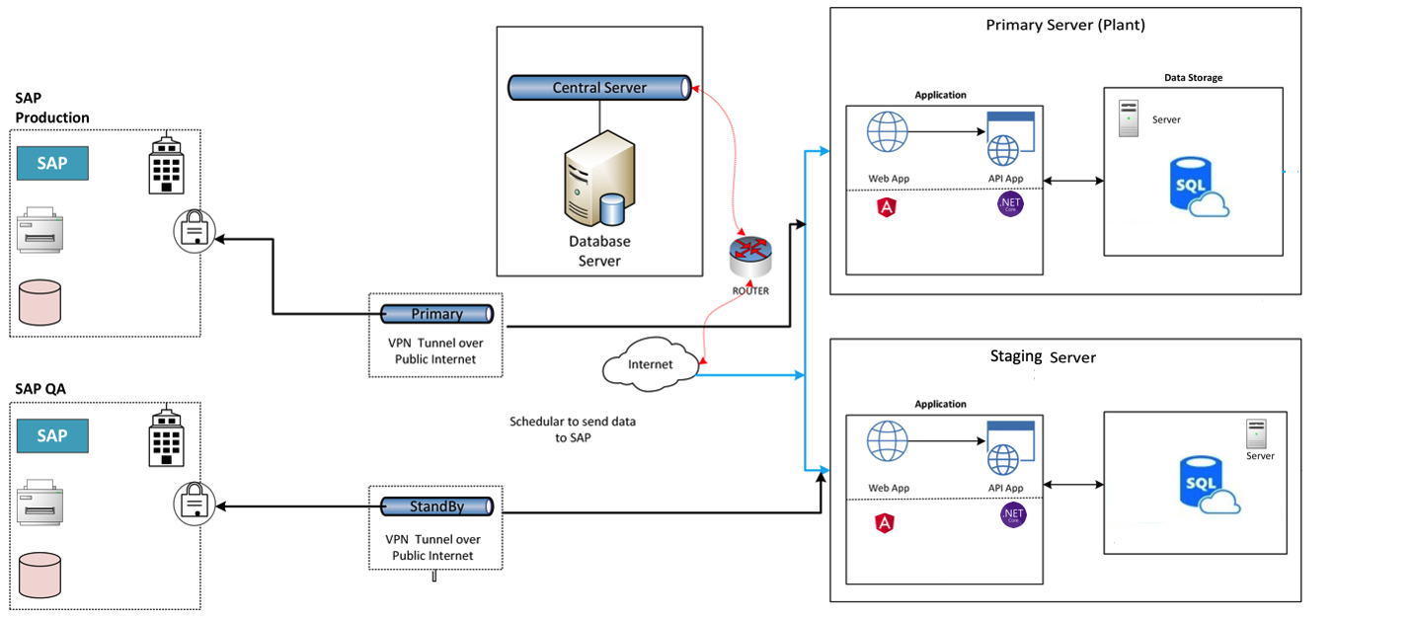
System Architecture
The architecture has the following components:
- Web: Web Frontend which is created using Angular 12 (A front end development language) and App services which are created using .Net core framework. App Service is a fully managed web hosting service for building web applications, services, and Restful APIs.
- Database: SQL database to keep data.
- Primary and Staging development Servers. We would be using two servers for production and staging development respectively
- Central Server (optional) of SQL Database, If needed we can use Central Database Server to ensure all plants data is synced if needed.
- SAP is connected to Plant side and not Central server. – All data will be updated directly in the SAP from BCI system, data transfer as per the process.

Object Model Workflow

Pharmision Code Data flow
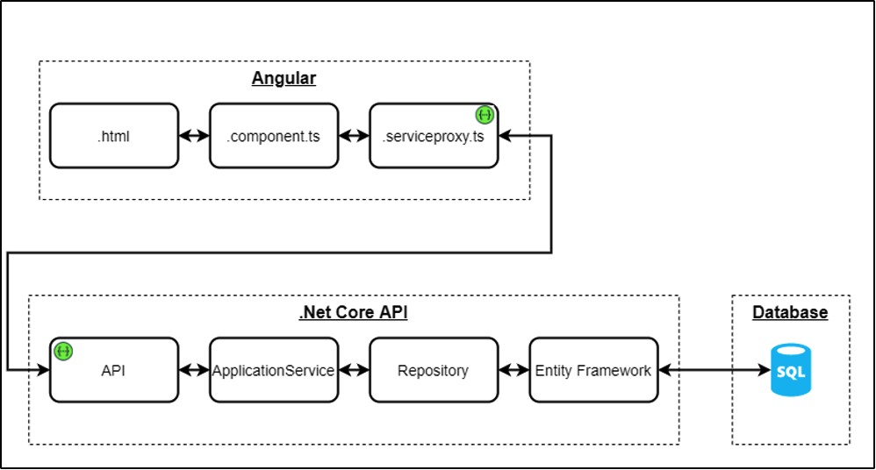

The above diagram shows the data flow that happens in code. Since our code is based on Angular and .Net core based API’s the diagram depicts the file types used in code architecture. Our Database is MSSQL and API’s can connect to MSSQL. For data modification or fetching.

Communication Flow ( SAP -BCI)
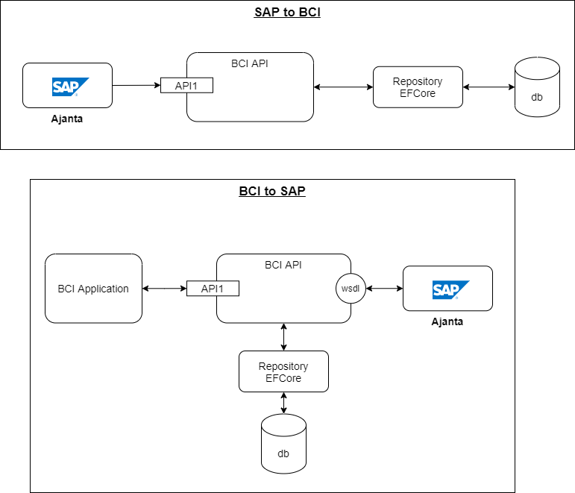

We have created a middleware connector in our code which communicates with SAP and Pharmision to keep the data in sync.

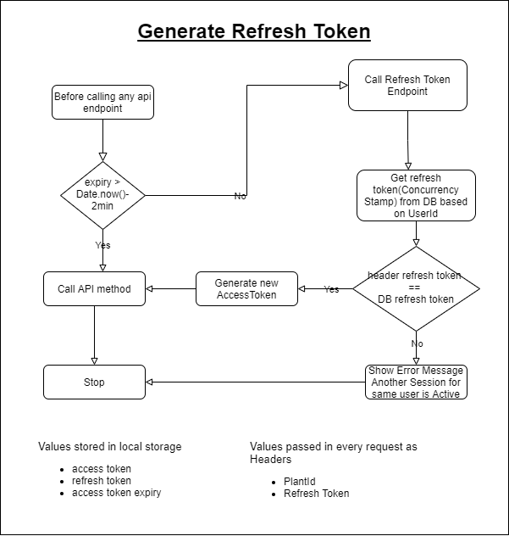
API Access Token

To ensure better security while calling API’s we use access Tokens which are generated or refreshed based on a time interval. If the access token is expired the API call will fail and system will be required to access Refresh token API. The API’s are under the access token control means to use this API’s password required which avoid any miss use of the API.

Hardware and Software Details

Hardware Details
- Zebra Desktop printer ZD23042-30GC00EZ
- Zebra Industrial printer ZT41142- T0G0000Z
- Zebra Industrial Tablet ET51CTG21
- Zebra Mobile Computer MC930BG
MobiVue PMMS Client:-
Since MobiVue PMMS client is a browser, it can run on any latest browser on any operating system.
Application Server :-
- System requirement for Pharmision is same as Angular 12 system requirements except that MobiVue PMMS will need additional RAM and computing power.
- Processor: 32-bit or 64-bit
- Desktop OS: Windows 10 any build
- Server OS: Windows Server 2016 onwards any server OS from Microsoft

Software Details
- Client (browser-based UI), Server (Web API), database connectors for standard RDBMS like MS SQL Server, Oracle, DB2 and device connectors for standard devices like weighing scale, scanners, printers
- Warehouse Management System (WMS) from Material Gate Entry to Dispatch of Materials.
- Work in Progress (WIP) for material and process tracking has been installed.
- Reports – Generation of different Process Reports
- Device Links:
- 172.16.200.28:4200/account/login
- 172.16.200.25:4200/account/login

Software Configuration Details:
We configure the application by using Internet Information services (IIS) for here we are using the below version.
IIS version: 10.0

Interfaces

Architecture
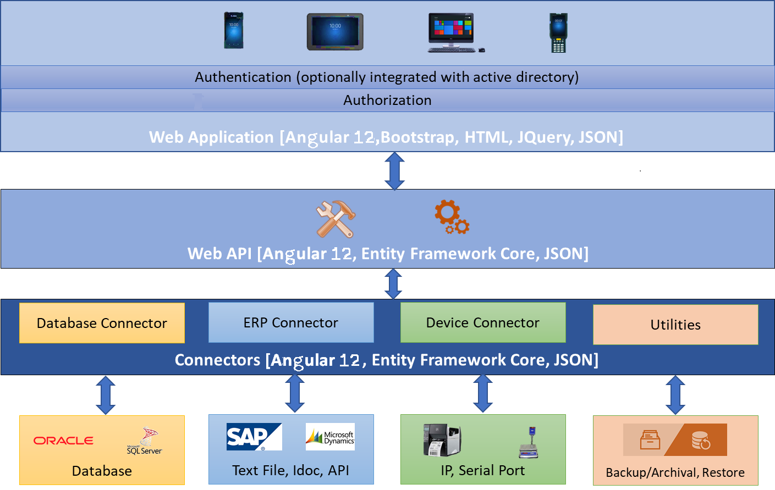
Pharmision is a web-based solution. This is developed on Model-View-Controller (MVC) architecture using Angular 12. All the components are integrated in a loosely coupled way to make the system robust, scalable and expandable. Especially, the connector layer that consists of database providers, 3rd party interfaces and device connectors are written in such a way that any of the connectors can be plugged in and out or changed. E.g. any RDBMS can be used as database, any ERP like SAP, MS Dynamics, etc. can be integrated, scanners of any make and model can be used for scanning etc. Following image shows the architecture of Pharmision representing all components of the system.

Component Descriptions

UI or Client Layer
UI is a browser-based interface managed and controlled by ASP.Net 3.1, HTML 5, CSS, Bootstrap, JQuery and JSON. All latest browsers will be supported for Pharmision on any operating system and any devices – be it a PC, Laptop, Tab or smart phone. To perform any operation or action on the system, users will need to be authenticated first.
Pharmision has its own authentication component which is forms-based authentication. User will provide username and password to login. Additionally, Pharmision authentication system can be integrated to customer’s own authentication system for extra level of security.
Once the user is authenticated, system will present the UI based on the access for the currently logged in user. Access for the user will be defined by the administrator.

Web API or Server Layer
Pharmision Web API will be the heart of the system. All business logic and data manipulations will be done in this layer. Web API will be secured through API Key security and this will not be known to the customer for whom the system is hosted. API Key will be a secret for everyone except the designated ones.

Connectors Layer
This will be most dynamic and loosely coupled component of Pharmision, to provide the flexibility of choice of databases, ERPs and devices.

WMS Application Flow
MobiVue Pharmaceutical Manufacturing Management System is developed and implemented for Ajanta Pharma Limited to automate system at Warehouse the solution will facilitate user to manage the storage of inventory at warehouse and also helps in efficient allocation of Material for Sampling and Dispensing. Barcode Labels will be generated for the received Material Packaging i.e. Containers or Bags against the Gate Entry Number. The barcode will be tracked through the material container movement i.e. Picking, staging, pre-staging ,stage-away, put-away during movement the materials will be validated against the the system input data . The application also provides identification for Equipment, Dispensing Booths, Weighing Machine, In-process machines, Pallets, Trolleys and process/dispensing rooms.
Pharmision application has been using the English (US) language for interface.

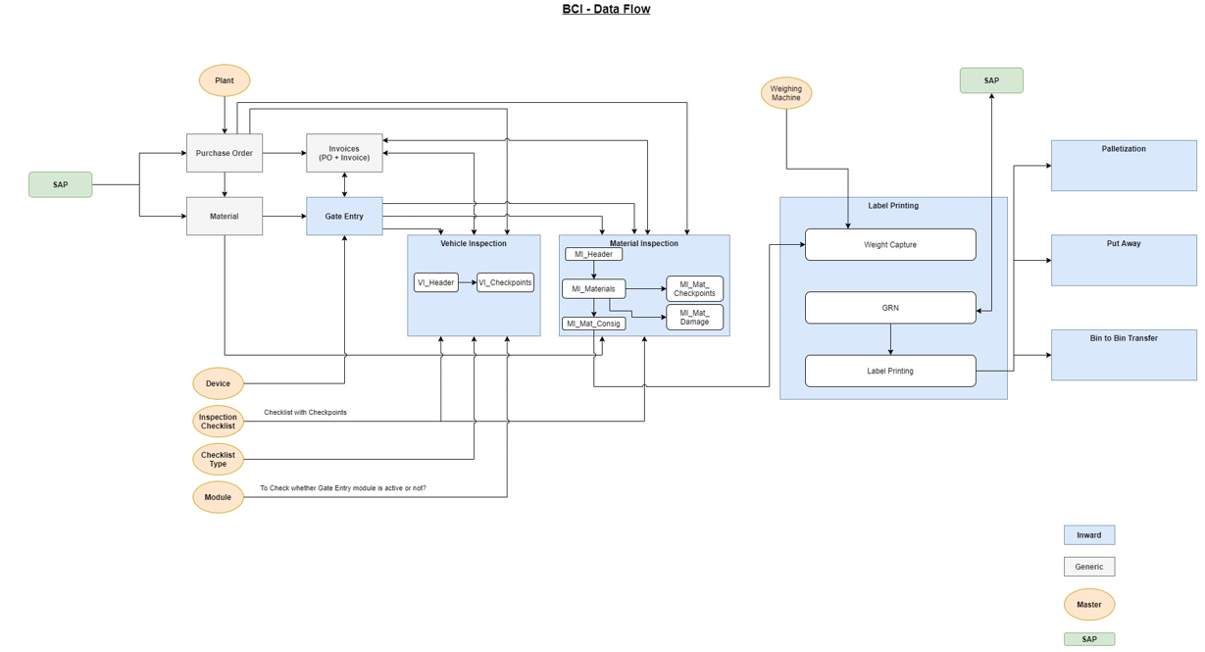
Flow Diagram for the Inward Process
Inward Module: - Basic function of the inward module is from material gate entry to storage in ware house and posting details in the SAP as per process .It consists of different sub modules as below
- Gate entry: - This sub module use to entry the materials in side factory premises after initial verification and data entry.
- Vehicle inspection: - This sub module use for verification of the vehicle in which the material transported as per the defined checklist.
- Material inspection: - In this module material verification carried out as per the defined checklist and enter the material data as per requirement.
- Weight/Quantity Verification: - In this module weight /quantity verification of the materials carried out as per the user requirement.
- GRN posting/Cancel/re-posting :- These modules use to post all the required data in to the SAP system and BCI system receive respond details from the SAP as per the process requirement
- Label printing :- In this module Bar code labels are printed for each container/pack as per the received material
- Palletization/Put away/Bin to Bin transfer: - These modules are use handle for handling & storage of the materials inside the ware house.

Flow Diagram for Sampling Process
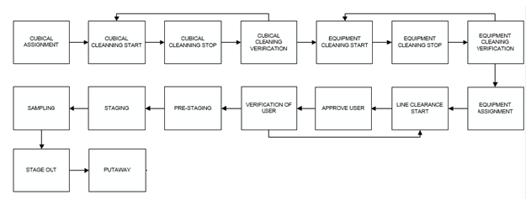
Sample destruction procedure to be check in system
Sampling Module: - Basic function of this module is to perform sampling of the materials as per the procedure. This module consist of below sub-modules
- Cubicle assignment: - This sub-module use for assignment/de-assignment of the cubicle to the materials for the sampling activity as per the planning.
- Cubicle cleaning: - Perform cleaning and cleaning verification of the cubicle as per the process and capture real time of the activity.
- Equipment Cleaning: - Basic function of this sub-module is to perform cleaning and cleaning verification of the equipment’s.
- Equipment assignment: - In this sub-module equipment assignment and de-assignment carried out for the sampling activity as per the planning.
- Line clearance: - This sub-module is use to perform line clearance of the cubicle i.e. checking and verification of the cubicle area as per the defined checklist based on the observation further process decided.
- Picking/Pre-Staging/Staging: - These sub-modules are used for the movement of the material from the material storage location to the sampling cubicle.
- Sampling: - This sub-module use for the sampling of the materials based on the unit of measurement the sampling can be done by performing weighing or counting the sample quantity.
- Stage out: - This sub-module use for handling the containers after completion of the sampling activity.
- Put-away: - This sub-module use for handling of the remaining materials and its storage.

Flow Diagram for Dispensing process

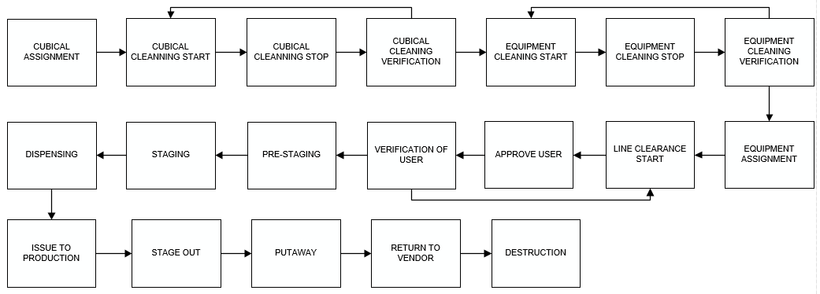
Palletization not mentioned in Dispensing FSD
For packing material flow to be change
Dispensing Module: - Basic function of this module is to dispense the materials as per the process order the production based on the unit of measurement and post the data details to the SAP. This module consist of below sub-modules
- Cubicle assignment: - This sub-module use for assignment/de-assignment of the cubicle to the materials for the dispensing activity as per the planning.
- Cubicle cleaning: - Perform cleaning and cleaning verification of the cubicle as per the process and capture real time of the activity.
- Equipment Cleaning: - Basic function of this sub-module is to perform cleaning and cleaning verification of the equipment’s.
- Equipment assignment: - In this sub-module equipment assignment and de-assignment carried out for the dispensing activity as per the planning.
- Line clearance: - This sub-module is use to perform line clearance of the cubicle i.e. checking and verification of the cubicle area as per the defined checklist based on the observation further process decided.
- Picking/Pre-Staging/Staging: - These sub-modules are used for the movement of the material from the material storage location to the dispensing cubicle.
- Dispensing: - This sub-module use for the dispensing of the materials based on the unit of measurement the dispensing can be done by performing weighing or counting the quantity.
- Palletization – This sub-module is use for Palletization of the dispensed materials.
- Issue to production :- In this sub-modules basic function is to post the dispense material data to the SAP.
- Stage out: - This sub-module use for handling the containers after completion of the dispensing activity.
- Put-away: - This module use for handling of the remaining materials container after dispensing and its storage.

Electronic Log System:-
System shall maintain different internal logs for application.

Error Logs
These logs will contain any errors encountered during runtime for faster resolution of any problem post deployment. These logs are captured by the system for verification and trouble shooting of any abnormal observation during process activity. This will be under access of the developer level.

Audit Logs
These logs will monitor the activities of user who accessed the application, made changes to File/ Document and the time stamp of these activities.

Error, Alarm and Warning Messages
Application users will get error/ alarm/ warning messages in following conditions:
Error Message will appear:-
- In case, user entered incorrect Login credentials.
- If user has clicked on Forgot Password button without entering Employee Code.
- In case user has entered invalid/inactive user id/Email on Forgot Password & Reset Password screen.
- In case user has entered different Password in New Password and Confirm Password text fields.
- In case, user has entered one of the 3 previous Passwords during resetting Password.
- In case, length of the Password entered does not satisfy the max-min validation.
- In case, user tries to save details without entering a mandatory field.
- In case, user has entered invalid data in a mandatory field and tries to save the details.
- In case, user tries to save already existing details.
- In case, user has entered invalid data i.e. Purchase Order, Process orders, Material codes Number during Process
- In case, user has scanned an invalid barcode or duplicate barcode
Warning Message will appear:-
- If user has left the Employee Code textfield blank on Forgot Password screen.
- If a mandatory field has not been filled.
- If user selects any date prior to current date for Stamping Done On field in Weighing Machine Master module.
- If user selects Stamping Due On date prior to Stamping Done On date in Weighing Machine Master module.
- If user enters Capacity or Standard Weight of weighing scale with digits after decimal more than least count.

Security
The Pharmision system will be secured by implementing authentication and authorization features. The following image shows the difference between two (i.e. authentication and authorization).
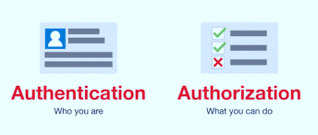

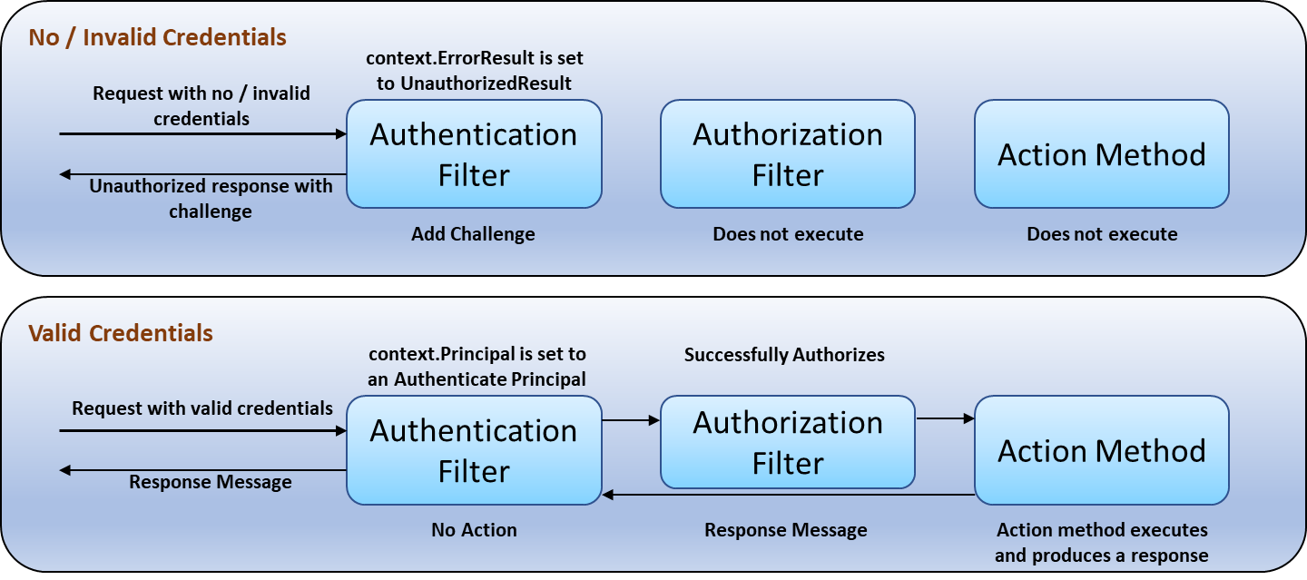
System will provide form-based authentication mechanism where user must provide valid username and password to log into the system. Each user must have an entry in the database with his/her username and password. Activity of adding a new user to the system will be done by the administrator of the system.

Authentication
Pharmision will have its own standard forms authentication module. Password will be stored in the database as an encrypted string, so that even someone with direct database access should not be able to see it.
Above image shows the flow for no or invalid credentials and valid credentials.

Authorization
The features / modules available in Pharmision will be input as seed. Administrator will only assign the access for these features / modules to individual roles of the users.
Above image shows the flow for no or invalid credentials and valid credentials.

Auditing
Every time a user logs in to or logs out of Pharmision, a corresponding entry will be done in the Audit Log table. Session outs are also tracked and audited.
A common module to insert the entry will be written. This module will not provide any update or delete actions for obvious reasons.

Plant Registration Details
Database Name on Ajanta Server will be as follows:
Production Database Name – AjantaDB
QA Database Name - AjantaDB_QA
Development Database Name - AjantaDB_Dev
Option will be provided to the authorized user for modifying the registered plant by providing details such as remark(s)/ Reason
* Plant code and DB Name will be in non-editable format
*Address will be in editable format

Application Modules

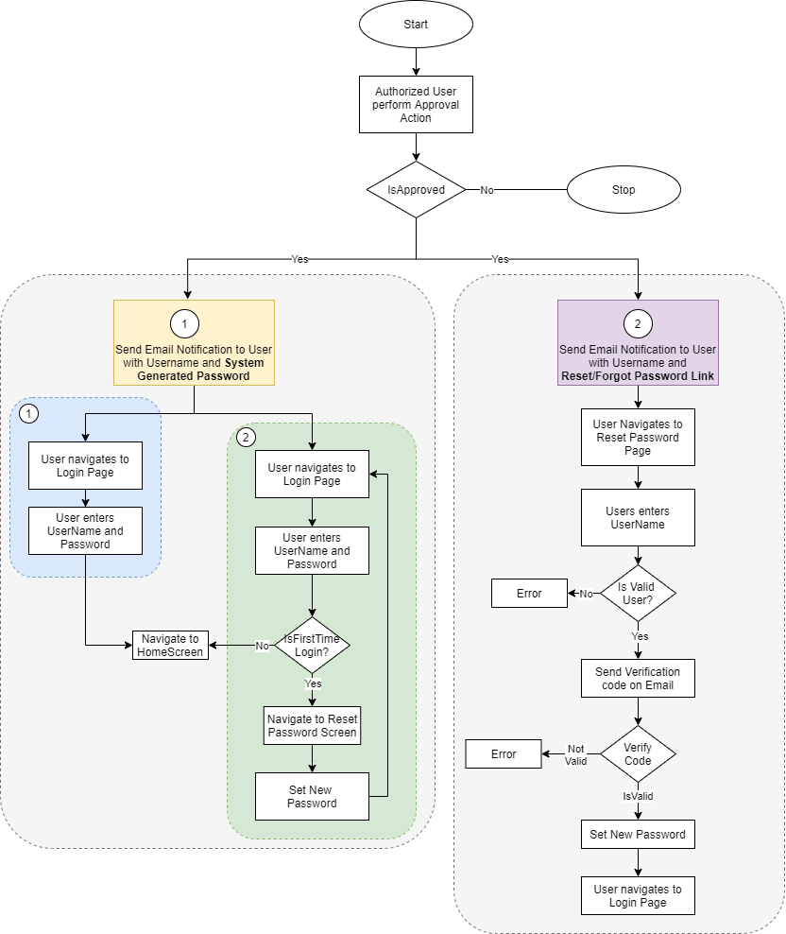
User Management
The module will let application administrator to manage the Users, and the rights assigned to the same; the rights will define authorized application access of users.
The User Management & Master data will be created using Web Application.

User Management Master
This module will let user to create application users who will access the application. To keep the system secured and track activities done by different users, user need to be registered to the system. System provides following functionalities to manage users. User master will be integrated with Active directory of customer.
The master will store the users’ details in system.
Note: Super user / Super Admin is a special user which is seeded during Pharmision hosting and not created using the Pharmision UI.
Data Fields | - First Name  - Last Name  - Phone Number  - Select Designation  - Select Reporting Manager  - Employee Code  - Email  - Remark  - Password  - Confirm Password  - Is Active  - Role
Process Steps | - Enter required details such as First Name, Last Name, and Phone Number.  - Select Designation, Sub Plant, and Reporting Manager from dropdown.  - Enter Employee Code, Email, Password, Confirm Password.  - Select Status as Is Active if it is active.  - Click on the add, in grid view its approval status will be displayed as submitted.  - Second authorized person will Approved / Reject after giving appropriate remark then the approval status will be updated accordingly.  - Save the details in database details will be display in grid.  - Grid view details as user first name, user last name, employee code, creation date, PW reset date, approval status, status and action.  - Based on the active /in active status will be display.  - By selecting the action details of the entry will be display.  - Selecting the back/cancel button user can return to the main grid screen from the particular screen without any change.
Functions | Add, edit and approve/reject the user as per the requirement.
Role | User Management

Role Management/ Permission
This module will let user to create specific role as per the user requirement.
Data Fields | - Role Name  - Display Name  - Description  - Remark  - Is Active  - Permissions
Process Steps | - Admin will enter the Role Name, Display Name, Remark and Description as per the requirement.  - Select Status as Is Active if role is active.  - Select the Permission by clicking on Module-Sub modules names in data grid.  - Save and Update the details in database and details will be display in grid view.  - Grid details as Role Name, Display Name, Description, Approval status, Status and Action.  - Based on the active /in active status will be display.  - By selecting the action details of the entry will be display.  - Selecting the back/cancel button user can return to the main grid screen from the particular screen without any change.
Functions | Add and approve/reject Roles as per requirement
Role | Role management

Password Management
This module will let Admin reset the password of application users after receive of the requisition. Once the password get reset by admin, then admin will share the password with the user and authorized users can access the application.
Data Fields | - First Name  - Last Name  - Employee Code  - Password  - Confirm Password
Process Steps | - First Name, Last Name, and Employee Code of the user whose password needs to reset will be displayed on the screen.  - Enter the password and confirm the Password, add the details.  - Admin can see the Status of User is changed pending to Submitted.  - User will guided by the system to change the password during 1st time log in.  - Admin can see the Status of User is changed Submitted to Completed.  - Save and Update the details in database details will be display in the grid.  - The grid display as employee code, first name, last name, request, status and action.  - In request column will show the reason for the password re-set.
Functions | Authorized user can reset password of users as per requirement after receive notification.

Remark: - Modules and Sub-modules are mentioned in the system to display no of modules and sub-modules available in the system. The module and sub-module do not have any functional activity in the process.

Masters

Plant Master
The plant master module will be used to create the Plant Master details in system. Different Plants in the organization will be mentioned here. Plant master will be created by Super Admin only.
Data Fields | - Plant Id  - Plant Name  - Select Plant Type  - Plant Description  - Tax Reg. No  - License  - GS1 Prefix  - Website  - Email  - Phone Number  - Address1  - Address2  - City  - Country  - State  - Postal Code  - Is Active
Process Steps | - Enter Plant Id.  - Enter Plant Name and Plant Description.  - Select Plant Type from dropdown i.e. Master Plant/ Sub Plant.  - Enter all details such as Tax Reg. No, License, GS1 Prefix Email, Phone Number, Website, Address1, Address2, City, State, Country, Postal Code.  - Select Status as Is Active if it is active.  - Save the details in database details will be display in grid as approval status submitted.  - Then Approved/Reject the plant after giving appropriate remark by selecting the action button.  - Save the details in database details will be display in grid.  - Grid view details as Plant ID, Plant type, Master plant ID, Country, Approval status, Status and Action.  - Based on the active /in active status will be display.  - By selecting the action details of the entry will be display.  - Selecting the back/cancel button user can return to the main grid screen from the particular screen without any change.
Functions | Add, edit and approve/reject the master as per the requirement.

Department Master
This master will contain Department details which will define department in plants.
Data Fields | - Department Code  - Select Sub Plant  - Department Name  - Department Description  - Remark  - Is Active
Process Steps | - Enter the Department Code..  - Select Sub Plant from dropdown.  - Enter Department Name, Remark and Description.  - Select Status as Is Active if it is active.  - Click on the add, in grid view its approval status will be displayed as submitted.  - Second authorized person will Approved / Reject after giving appropriate remark then the approval status will be updated accordingly.  - Save the details in database details will be display in grid.  - Grid view details as Sub-plant, Department code, Department name, Approval status, Status and Action.  - Based on the active /in active status will be display.  - By selecting the action details of the entry will be display.  - Selecting the back/cancel button user can return to the main grid screen from the particular screen without any change.
Functions | Add, edit and approve/reject the master as per the requirement.

Area Master
This master will contain Area details which will define Area in Departments.
Data Fields | - Area Code  - Area Name  - Area Description  - Select Sub Plant  - Select Department  - Remark  - Is Active
Process Steps | - User will enter Area Code.  - Enter Area Name and Area Description.  - Select Sub Plant and Department from dropdown.  - Enter Remark.  - Select Status as Is Active if it is active.  - In grid view its approval status will be displayed as submitted.  - Second authorized person will approve / reject after giving appropriate remark details will be updated under approval status.  - Save the details in database details will display in grid.  - Grid details as Sub-plant ID, Area code, Area name , Approval status ,Status and Action  - Based on the active /in active status will be display.  - By selecting the action details of the entry will be display.  - Selecting the back/cancel button user can return to the main grid screen from the particular screen without any change.
Functions | Add, edit and approve/reject the master as per the requirement.

Cubicle Master
This master will contain Cubicle details which will define cubicle in area.
Data Fields | - Cubicle Code  - Cubicle Name  - Select Sub Plant  - Select Department  - Cubicle Description  - Select Area  - Remark  - Is Active
Process Steps | - Enter Cubicle Code and Cubicle Name.  - Select Sub Plant and Department from the dropdown  - Enter Cubicle Description.  - Select Area from the dropdown.  - Enter Remark.  - Select Status as Is Active if it is active and click on add.  - In grid view its approval status will be displayed as submitted.  - Second authorized person will approve / Reject after giving appropriate remark by selecting the action from grid.  - Save the details in database details will be updated in grid.  - Grid view display as Sub-Plant ID, Cubicle code, Approval status, Status and Action  - Based on the active /in active status will be display.  - By selecting the action details of the entry will be display.  - Selecting the back/cancel button user can return to the main grid screen from the particular screen without any change.
Functions | Add, edit and approve/reject the master as per the requirement.

Bin Locations Master
This master will contain Bin location details which will define bin location in plant.
Data Fields | - Bin Location Code  - Rack Name  - Select Sub Plant  - Location Description  - Select Department  - Select Area  - Remark  - Is Active
Process Steps | - Enter Bin Location Code, Rack Name.  - Enter Location Description.  - Select, Sub Plant, Department, and Area from dropdown.  - Enter Remark. .  - Select Status as Is Active if it is active.  - In grid view its approval status will be displayed as submitted.  - Second authorized person will approve / reject after giving appropriate remark by selecting the action from the grid.  - Save the details in database and details will be display in grid.  - The grid display as Bin location, rack name, area name, sub-plant ID, approval status, status and action.  - Based on the active /in active status will be display.  - By selecting the action details of the entry will be display.  - Selecting the back/cancel button user can return to the main grid screen from the particular screen without any change.
Functions | Add, edit and approve/reject the master as per the requirement.

Equipment Master

Data Fields | - Equipment Code  - Equipment Name  - Equipment Alias  - Select Sub Plant  - Select Department  - Select Area  - Cubicle Barcode  - Equipment Description  - Select Equipment type  - Vendor Name  - Clean Hold Time (In Hrs)  - Remark  - Is Portable  - Is Active
Process Steps | - Enter Equipment Code, Equipment Name, Equipment Alias, Cubicle Barcode, and Equipment Description.  - Select Sub Plant, Department, Area, Equipment Type, from the dropdown.  - Enter Vendor Name, Equipment Type.  - Enter Clean Hold Time (In Hrs.).  - Select the checkbox of Is Portable, and Is Active status as applicable.  - In grid view its approval status will be displayed as submitted.  - Second authorized person will Approved / Reject after giving appropriate remark and details will be updated in approval status by selecting the action from the grid.  - Save the details in database and details will be display in the grid.  - The grid view is as Sub-Plant ID, Equipment code, Equipment Type, Department Name, Area Name, Approval status, status and Action.  - Based on the active /in active status will be display.  - By selecting the action details of the entry will be display.  - Selecting the back/cancel button user can return to the main grid screen from the particular screen without any change.
Functions | Add, edit and approve/reject the master as per the requirement.

Handling Units Master
A Handling Unit is a physical unit used for caring the materials
Data Fields | - Handling Unit Code  - Select Sub Plant  - Handling Unit Name  - Handling Unit Description  - Remark  - Is Active
Process Steps | - Enter Handling Unit Code.  - Select Sub Plant from dropdown.  - Enter Handling Unit Name, Description, and Remark.  - Select Status as Is Active if it is active.  - Select add, in grid view its approval status will be displayed as submitted.  - Second authorized person will approve / reject after giving appropriate remark and details will be updated under approval status.  - Save the details in database and details will be display in grid view.  - The grid view details as sub-plant ID, handling unit code, name approval status, status and action.  - Based on the active /in active status will be display.  - By selecting the action details of the entry will be display.  - Selecting the back/cancel button user can return to the main grid screen from the particular screen without any change.
Functions | Add, edit and approve/reject the master as per the requirement. .

Gates Master
All inward stock movement starts, and all outward movement ends through Gate. Gate pass is generated at the gate which helps controlling vehicle movement inside a plant.
Data Fields | - Name  - Gate Code  - Select Sub Plant  - Gate Description  - Alias Name (if any)  - Remark  - Is Active
Process Steps | - Enter Gate Name.  - Enter Gate Code.  - Select Sub Plant from dropdown.  - Enter Gate Description.  - Enter Alias Name (if any).  - Select Status as Is Active if it is active.  - After selecting the add button in grid view approval status will be displayed as submitted.  - Second authorized person will approve / reject after giving appropriate remark.  - Save the details in database and details display in the grid view  - The grid view details as plant name, plant code, gate code, approval status, status and action.  - Based on the active /in active status will be display.  - By selecting the action details of the entry details will be display.  - Selecting the back/cancel button user can return to the main grid screen from the particular screen without any change.
Functions | Add, edit and approve/reject the master as per the requirement.

Checklist Type Master
Check List Type master will be used to display the type of checklist
Data Fields | - Select Sub Plant  - Select Sub Module  - Checklist Type Name  - Remark  - Is Active
Process Steps | - Select Sub Plant and Sub Module from Dropdown.  - Enter Checklist Type Name, Remark.  - Select Status as Is Active if it is active.  - Click on add, in grid view its approval status will be displayed as submitted.  - Second authorized person will approve / Reject after giving appropriate remark.  - Save the details in database and details will be display in grid.  - The grid view as sub-plant, sub-module, checklist type name, approval status, status and action.  - Based on the active /in active status will be display.  - By selecting the action details of the entry will be display.  - Selecting the back/cancel button user can return to the main grid screen from the particular screen without any change.
Functions | Add, edit and approve/reject the master as per the requirement.

Checklists Master
Inspection Checklist is used in various activities like vehicle inspection, material inspection, cubicle cleaning, line clearance for cubicle etc. Checklist will be created as per the module and will be displayed in that specific module only.
Data Fields | - Checklist Name  - Select Sub Plant  - Select Sub Module  - Checklist Description  - Format Number (SOP No.)  - Select Checklist Type  - Remark  - Is Active  - Checkpoints:  - Checkpoint Name  - Select Checkpoint Type (Text/ Options/Condition)  - Select Checkpoint Mode (Production/Quality/Store)  - Value Tag  - Acceptance Value
Process Steps | - Enter Checklist Name and Checklist Description.  - Select Sub Plant and Sub Module from dropdown.  - Enter Format Number (SOP No.).  - Select Checklist Type from the dropdown.  - Enter Remark.  - Select Status as Is Active if it is active.  - Enter Checklist Name in Checkpoints.  - Select Checkpoint Type from the dropdown. (Text/ Options/Condition)  - Select Checkpoint Mode from the dropdown.  - Enter Value Tag and Acceptance Value.  Value Tag :-  Condition - Please enter valid value tag. Use (" <","<=","<",">=") while entering values.  Option: - Please enter valid value tag. Use "|" as separator while entering values. e.g ("Value1|Value2|Value3").  - Enter the acceptance value.  - Select the add, in grid view its status will be displayed as submitted.  - Second authorized person will Approve / Reject after giving appropriate remark.  - Save the details in database and details will be display in the grid.  - The grid view display as sub-plant ID, checklist name, sub module, approval status, status, action.  - Based on the active /in active status will be display.  - By selecting the action details of the entry will be display.  - Selecting the back/cancel button user can return to the main grid screen from the particular screen without any change.
Functions | Add, edit and approve/reject the master as per the requirement.

Weighing Balance Master
This master will contain Weighing Machine details. With the help of this master, user will create master list for the balances for Weighing Machine to provide unique identification to each Weighing Machine at Store and will be able to update the required Weighing Machine details.
Data Fields | - Details:  - Select Balanced Type (Analytical/Normal)  - Weighing Balance Code  - Select Sub Plant  - Select Unit of Measurement  - Select Department  - Select Area  - Cubicle Barcode  - IP ID Address  - Port Number  - Model  - Make  - Least Count  - Least Count Digit After Decimal  - Minimum Operating Capacity  - Maximum Operating Capacity  - Stamping Done On  - Stamping Due On  - Capacity  - Eccentricity Standard Weight Value  - Eccentricity Acceptance Min Value  - Eccentricity Acceptance Max Value  - Eccentricity Instruction  - Linearity Standard Weight Value (Weight 1)  - Linearity Acceptance Min Value (Weight 1)  - Linearity Acceptance Max Value (Weight 1)  - Linearity Standard Weight Value (Weight 2)  - Linearity Acceptance Min Value (Weight 2)  - Linearity Acceptance Max Value (Weight 2)  - Linearity Standard Weight Value (Weight 3)  - Linearity Acceptance Min Value (Weight 3)  - Linearity Acceptance Max Value (Weight 3)  - Linearity Standard Weight Value (Weight 4)  - Linearity Acceptance Min Value (Weight 4)  - Linearity Acceptance Max Value (Weight 4)  - Linearity Standard Weight Value (Weight 5)  - Linearity Acceptance Min Value (Weight 5)  - Linearity Acceptance Max Value (Weight 5)  - Linearity Instruction  - Repeatability Standard Weight Value  - Repeatability Acceptance Min Value  - Repeatability Acceptance Max Value  - Repeatability Instruction  - Uncertainty Acceptance Value(NMT%): fixed 0.001  - Uncertainty Instruction  - Select Frequency  - Reference SOP No  - Format No  - Version  - Remark  - Is active  - Is Compulsory use  - Remark  - Balance Calibration Test Configuration:  - Select Frequency  - Test Type: Eccentricity Test, Linearity Test, Repeatability Test, Uncertainty Test  - Balance Verification Test configuration :  - Select Frequency  - Calibration Level  - Calibration Criteria  - Standard Weight  - Minimum Value  - Maximum value
Process Steps | - Details:  - Select Balanced Type (Analytical/Normal), Select Sub Plant, Select Unit of Measurement, Department, Area from dropdown.  - Enter Cubicle Barcode, Weighing Machine Code, IPID Address, Port Number, Model, Make, Least Count, Minimum Operating Capacity, Maximum Operating Capacity.  - Select Stamping Done On, Stamping Due On from the calendar.  - Enter Capacity, Eccentricity Standard Weight Value, Eccentricity Standard Max Value, Eccentricity Standard Weight Min Value, and Eccentricity Instruction.  - Enter Linearity Standard Weight Value, Linearity Acceptance Min Value, Linearity Acceptance Max Value, and Linearity Instruction.  Note: (User can enter the Linearity values for weight 1 to weight 5)  - Enter Repeatability Standard Weight Value, Repeatability Acceptance Min Value, Repeatability Acceptance Max Value, and Repeatability Instruction.  - Select Frequency from dropdown. (Daily Verification, Monthly & Weekly calibration)  - Enter Reference SOP No, Format No, Version, Remark.  - Select Is active if it is active.  - Select Is Compulsory us if it is compulsory to use.  - Remark  Note: Uncertainty Acceptance Value(NMT%) is fixed as 0.001  - Balance Calibration Test Configuration:  - Select Frequency from dropdown. . (Daily Verification, Monthly & Weekly calibration)  - Select Test Type: Eccentricity Test, Linearity Test, Repeatability Test, Uncertainty Test.  - Click on Add button.  - Balance Verification Test Configuration:  - Select Frequency from dropdown. . (Daily Verification, Monthly & Weekly calibration)  - Enter Calibration Level, Calibration Criteria, Standard Weight, Minimum Value, Maximum value  - Click on Add button to save the details in the database.  - In grid view its approval status will be displayed as submitted.  - Second authorized person will Approve / Reject after giving appropriate remark.  - Save the details in database details will be display in the grid view.  - The grid view details as sub-plant, weighing balance code, Unit of measurement, Make, Model, approval status, status and action.  - Based on the active /in active status will be display.  - By selecting the action details of the entry details will be display.  - Selecting the back/cancel button user can return to the main grid screen from the particular screen without any change.
Functions | Add, edit and approve/reject the master as per the requirement.

Standard Weight Boxes Master
This master will contain Standard Weight Box details which are used while weighing balance calibration and verification. In this master Standard Weight Box ID will be maintain as unique id.
Data Fields | - Standard Weight Box Id  - Select Sub Plant  - Select Department  - Select Area  - Standard Weight Box Description  - Remark  - Is Active
Process Steps | - Enter Standard Weight Box Id.  - Select Sub Plant, Department, and Area from the dropdown.  - Enter Standard Weight Box Description, Remark.  - Select Status as Is Active if it is active.  - In grid view its approval status will be displayed as submitted.  - Second authorized person will Approve / Reject after giving appropriate remark.  - Save the details in database details will be display in grid view  - The grid view details as sub-plant IS, standard weight box ID, area name , department name, approval status, status and action.  - Based on the active /in active status will be display.  - By selecting the action details of the entry will be display.  - Selecting the back/cancel button user can return to the main grid screen from the particular screen without any change.
Functions | - Add, edit and approve/reject the master as per the requirement.

Standard Weight Master
This master will contain Standard Weight details which are used while weighing balance calibration and verification. In this master Standard weight ID will be maintain as unique id.
Data Fields | - Standard Weight Id  - Select Sub Plant  - Select Department  - Standard Weight Description  - Select Area  - Capacity  - Select Unit of Measurement  - Select Standard Weight Box  - Stamping Done On  - Stamping Due On  - Remark  - Is Active
Process Steps | - Enter Standard Weight ID.  - Select Sub Plant, Department from the dropdown.  - Enter Standard Weight Description, Capacity.  - Select Area, Unit of Measurement, and Standard Weight Box from the dropdown.  - Select Stamping Done On and Stamping Due On dates from the calender.  - Enter Remark.  - Select Status as Is Active if it is active.  - In grid view its approval status will be displayed as submitted.  - Second authorized person will Approve / Reject after giving appropriate remark.  - Save the details in database and details will be display in grid.  - The grid view display as sub-pant ID, standard weight ID, capacity, area name, department name, approval status, status and action.  - Based on the active /in active status will be display.  - By selecting the action details of the entry will be display.  - Selecting the back/cancel button user can return to the main grid screen from the particular screen without any change.
Functions | Add, edit and approve/reject the master as per the requirement.

Devices Master
This master will store Devices details so system can have details of all the devise information as Mobile device, Printer and tablets and maintain the connection parameters. Through which the devices will be accessible in network.
Data Fields | - Device Id  - Select Sub Plant  - Select Device Type (Mobile devices/Printer/Tablet)  - Select Mode (Production/Quality/Store)  - IP Address  - Port  - Make  - Model  - Serial Number  - Select Department  - Select Area  - Select Cubicle  - Remark  - Is Active
Process Steps | - Enter Device Id, it can be alpha numeric.  - Select Sub Plant from dropdown.  - Select Device Type (Mobile Devices /Printer/Tablet) from dropdown.  - Select Mode (Production/Quality/Store) from dropdown.  - Enter other details such as IP Address, Port, Make, Model, and Serial Number.  - Select Department, Area, and Cubicle from dropdown.  - Select Status as Is Active if it is active.  - In grid view its approval status will be displayed as submitted.  - Second authorized person will Approve / Reject after giving appropriate remark.  - Save the details in database and details will be display in the grid view.  - The grid view will be display as device ID, sub-plant ID, device type, make, model, approval status, status and action.  - Based on the active /in active status will be display.  - By selecting the action details of the entry will be display.  - Selecting the back/cancel button user can return to the main grid screen from the particular screen without any change.
Functions | Add, edit and approve/reject the master as per the requirement.

Activity Master
This master will contain Activity details which are used while process activity.
Data Fields | - Activity Name  - Activity Code  - Activity Description  - Select Module Name  - Select Sub Module Name  - Remark  - Is Active
Process Steps | - Enter Selec Activity Name from dropdown.  - Enter Activity Code, and Activity Description.  - Select Module Name, Sub Module Name.  - Enter Remark  - Select Status as Is Active if it is active.  - In grid view its approval status will be displayed as submitted.  - Second authorized person will Approve / Reject after giving appropriate remark.  - Save the details in database and details will be display in grid.  - The grid view display as activity name, activity code, module, sub-module, description, approval status, status and action.  - Based on the active /in active status will be display.  - By selecting the action details of the entry will be display.  - Selecting the back/cancel button user can return to the main grid screen from the particular screen without any change.
Functions | Add, edit and approve/reject the master as per the requirement.

Transporter Master
This master will contain details of the list of transporters.
Data Fields | - Transporter Name  - Transporter Description  - Remark  - Is Active
Process Steps | - Enter Transporter Name, Transporter Description, and Remark.  - Select Status as Is Active if it is active.  - In grid view its status will be displayed as submitted.  - Second authorized person will Approve / Reject after giving appropriate remark and approval status will be updated accordingly.  - Save the details in database and details will display in grid.  - The grid display as transporter name, description, remark, approval status, status and action.  - Based on the active /in active status will be display.  - By selecting the action details of the entry will be display.  - Selecting the back/cancel button user can return to the main grid screen from the particular screen without any change.
Functions | Add, edit and approve/reject the master as per the requirement.

SAP Storage Location Master
This master will used to mentain details of SAP Storage Location.
Data Fields | - SAP Storage Location Name  - SAP Storage Location Description  - Remark  - Is Active
Process Steps | - .Enter SAP Storage Location Name, SAP Storage Location Description, Remark.  - Select Status as Is Active if it is active.  - In grid view its approval status will be displayed as submitted.  - Second authorized person will Approve / Reject after giving appropriate remark the status column will be updated accordingly.  - Save the details in database details will be display in the grid  - The grid view display as sap storage location name, description, approval status, status and action.  - Based on the active /in active status will be display.  - By selecting the action details of the entry will be display.  - Selecting the back/cancel button user can return to the main grid screen from the particular screen without any change.
Functions | Add, edit and approve/reject the master as per the requirement.

Inward

Gate Entry
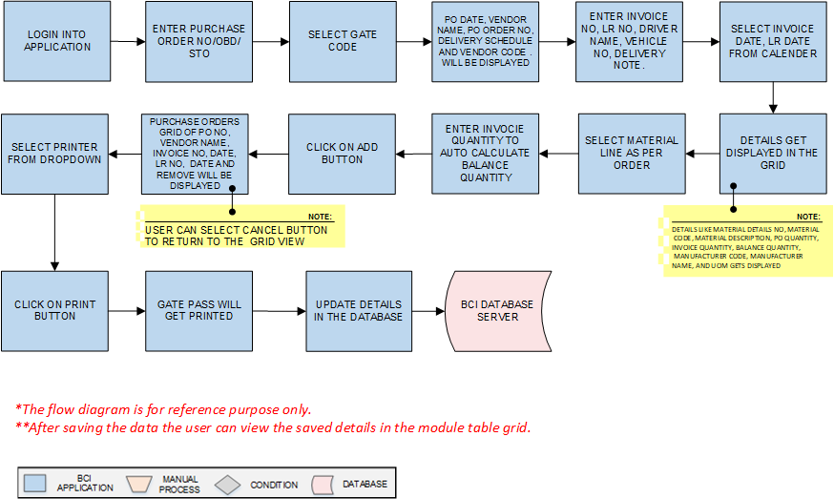
Activities
Module Description | Gate Pass activities controls and manage the material vehicle movement inside the plant for unloading the material.

Pre-Conditions | - Purchase Order No/ OBD/STO details should pushed from SAP to BCI system.

Process Steps | - User will login into Application.  - Enter Purchase Order No/ OBD/STO.  - Select Gate Code from dropdown  - PO Date, Vendor Name, PO Order No Delivery Schedule and Vendor Code will be displayed  - Enter Invoice No, , LR No, Driver Name, Vehicle No, Delivery note  - Select Transporter Name.  - Select Invoice Date, LR Date from the calendar.  - A grid format of Material details No, Material Code, Material Description, PO Quantity, Invoice Quantity, Balance Quantity, Manufacturer Code, Manufacturer Name, and UOM will displayed on the screen  - Select the material lines as per received material and enter the invoice quantity system will auto calculate the balance quantity  - Click on Add button.  - Purchase Orders Grid of PO No, Vendor Name, Invoice No, Invoice Date, LR No, LR Date, and Remove will appear on the screen.  - By selecting the cancel button user can return to the grid view without saving any data.  - Select printer from dropdown.  - Click on Print button.  - Gate Pass will get printed.  - Update the details in the database in grid view.  - The grid view is as Created date, Gate entry no , Purchase order no/OBD/STO,LR No., Done By, Status and action  - Status column will show the status of the gate entry i.e. active/in-active  - Selecting the action button user can display details of the gate entry  *Authorized user can edit, view, cancel, re-print and back the screen as per requirement by entering appropriate remark.  System will not allow the cancel gate entry to proceed for the next step and the balance quantity will be updated as per the cancelled invoice quantity.

Post-Conditions | - Gate Pass barcode label should be available at the unloading bay.

Validations | - An alert should be displayed in case duplicate/ invalid Purchase Order No is entered.  - An alert should be displayed in case duplicate Invoice No is entered.  - An alert should be displayed in case Purchase Order details are not fetched from SAP.

Vehicle Inspection
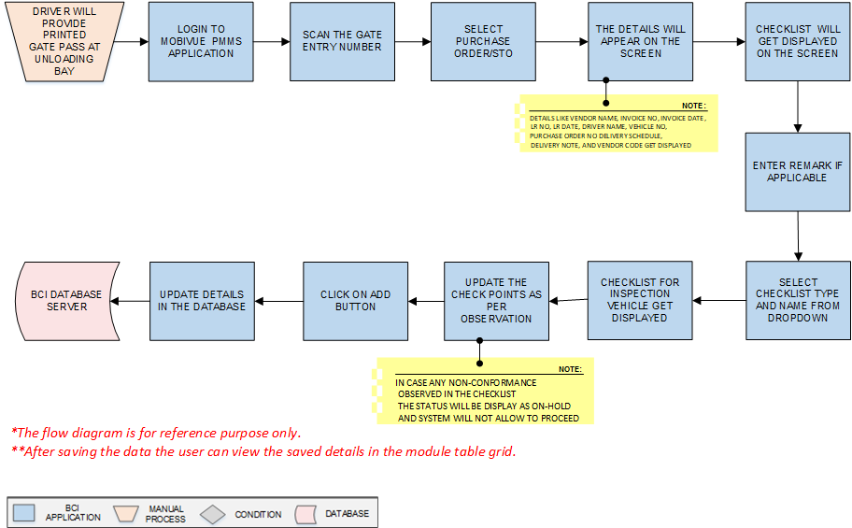
Activities
Module Description | Before unloading material from the vehicle, vehicle will be inspected against the defined checklist.

Pre-Conditions | - Printed Gate Pass should be available.  - Checklist should available in Checklist master.

Process Steps | - Driver will provide printed Gate Pass at the unloading bay Gate entry.  - User will login in MobiVue PMMS system.  - Scan the Gate Entry No Number .  - Select Purchase Order/STO.  - Details such as Vendor Name, Invoice No, Invoice Date, LR No, LR Date, Driver Name, Vehicle No, Purchase Order No Delivery Schedule, Delivery Note, and Vendor Code (as applicable) will appear on the screen.  - Enter the remark as applicable.  - Select checklist Type as required from dropdown.  - Select checklist Name as required from dropdown.  - Checklist for inspection of vehicle will appear on the screen.  - Update the check points as per the observation.  *In case any non-conformance observed in the checklist the status will be display as on-hold and system will not allow to proceed next step.  - Click on Add button.  - Inspection will be completed.  - Update the details in the database details will display in the grid.  - Grid view as Created date, Gate entry no., Purchase order STO, Invoice no., Invoice date, done by, status and action.  - Under status column status of the process will be display.  - By selecting the action details of the entry will be display.  - Selecting the back/cancel button user can return to the main grid screen from the particular screen without any change.  - If authorized user after selecting the action, accept the entry then it will allow to proceed next step.  *Authorized user can edit, view, hold, accept and reject after entering appropriate remark.

Post-Conditions | - Vehicle inspection will be completed.

Validations | - An alert should be displayed in case invalid Gate Entry No is scanned.  - An alert should be displayed in case duplicate/ invalid Purchase Order is selected.

Material Inspection
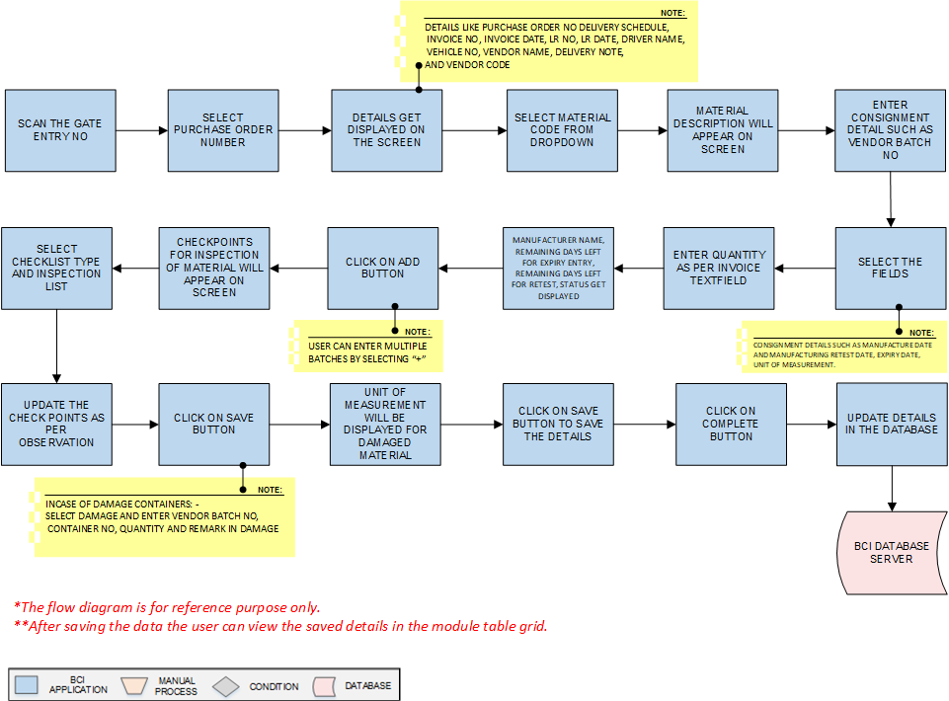
Activities
Module Description | In this module material is inspected after the material has received at the plant.

Pre-Conditions | - Gate Pass should be available for scanning.  - Vehicle Inspection should be completed.

Process Steps | - Scan the Gate Entry No.  - Select Purchase Order from dropdown.  - Details such as Purchase Order No Delivery Schedule, Invoice No, Invoice Date, LR No, LR Date, Driver Name, Vehicle No, Vendor Name, Delivery Note, and Vendor Code (as applicable) will appear on the screen.  - Select Material Code from dropdown for Material details.  - Material Description will appear on the screen.  - Enter Consignment Details such as Vendor Batch No.  - User will select Consignment details such as Manufacture Date and Manufacturing Retest Date, Expiry Date, Unit of Measurement.  - Enter Quantity as per Invoice, Text Filled  - Manufacturer Name, Remaining days left for expiry remaining days left for Retest, Status will displayed on screen.  - Click on add button to save Consignment details  - User can enter multiple batches by selecting “+” sign  - Checkpoints for Material inspection will appear on the screen.  - Select Checklist Type and Inspection Checklist for checkpoints from dropdown.  - Update the checklist as per observation.  - Click on Save button to save the checkpoint details.  - EnterSelect damage In case of damage containers: - Select damage and enter Vendor Batch No, Container No, Quantity and Remark in Damage section if the material is damaged.  - Unit of measurement will be displayed for the damaged material.  - Click on save button to save the details.  - Click on Complete button to complete the process.  - Update the details in database and display in grid view  - Grid view display as Created date, Gate entry no., Purchase order STO, Invoice no., Invoice date, Material code, Material name, done by, status and action.  - Under status column status of the process will be display.  - By selecting the action details of the entry will be display.  - Selecting the back/cancel button user can return to the main grid screen from the particular screen without any change.  - In case any non-conformance observed in the checklist the status will be change and system will not allow to proceed next step.  - If authorized user after selecting the action, accept the entry then it will allow to proceed next step.  *Authorized user can edit, view, hold, accept and reject after entering appropriate remark.

Post-Conditions | - Material inspection will be completed.

Validations | - An alert should be displayed in case invalid Gate Entry No is scanned.  - An alert should be displayed in case duplicate/ invalid Purchase Order is selected.

Weight Quantity/Verification
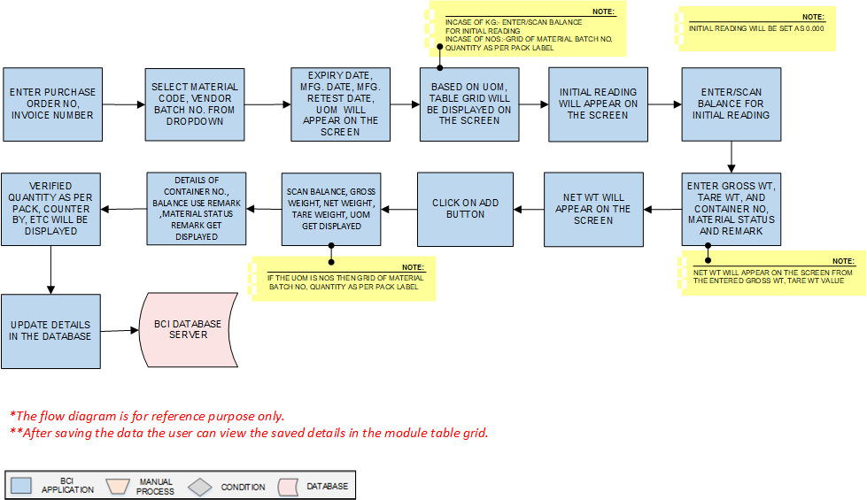
Activities
Module Description | In this module, the Weight/Quantity verification of the material will be carried out

Pre-Conditions | - Material Inspection should be completed.  - Calibrated Weighing Balance master should be available.(If applicable )

Process Steps | - Enter Purchase Order No, Invoice Number.  - Select Material Code, Vendor Batch No. from dropdown.  - Expiry Date, Mfg Date, Mfg. Retest Date, UOM of the selected material will appear on the screen.  - Based on UOM, table grid will be displayed on the screen.  - In case of UOM in KG:- Enter/Scan Balance for Initial reading.  - Initial reading will appear on the screen.  - Enter/Scan balance Id.  - Enter Gross Wt, weight, Tare Weight, and Container No, Material Status Remark.  *Net Weight will appear on the screen calculating from the entered Gross Weight, Tare Weight value.  - Net weight will appear on the screen.  - Click on Add button.  - Grid of balances (if the UOM KG) such as Scan Balance, Gross weight, Net weight, Tare weight, UOM, Container No., Balance use remark ,Material Status Remark and action will appear on the screen.  - Incase UOM is NOS then grid of Material Batch No, quantity as per pack label.  - Verified quantity as per pack, Counter by, Remark will appear on the screen.  - Details will get saved in database and display in grid view.  - Grid view as Created date, Gate entry no., Purchase order/ STO, Invoice no., Material code, Material name, Vendor batch no. done by and action.  - User will be able to delete the entry details after click on the delete button and entering the remark  - Clicking on the back button user will back to the grid view  - Authorized user can able to add the data by selecting the edit button.

Post-Conditions | - Weight/Quantity verification Capture details get in displayed.

Validations | - An alert should be displayed in case duplicate/invalid Purchase Order is entered.  - An alert should be displayed in case duplicate/invalid Invoice Number is selected.  - An alert should be displayed in case of Initial reading will not set to zero (There will be no alert message incase offline balance use).

GRN Posting
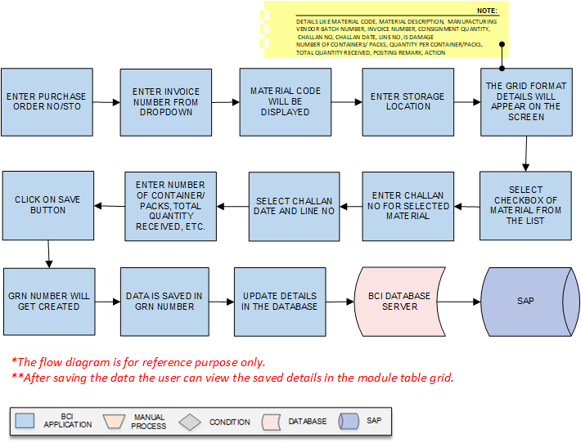
Activities
Module Description | In this module the inspected data of Material, Weight Capture details are submitted to SAP.

Pre-Conditions | Weight /Quantity verification of the materials should completed

Process Steps | - Enter Purchase Order /STO.  - Enter Invoice Number  - Select Materials will be displayed.  - Enter Storage Location.  - After selection of the material a grid format of Material Code, Material Description, Vendor Batch Number, Invoice Number, Consignment Quantity, Challan No, Challan Date, Line No, Is Damage, Number of Containers/ Packs, Quantity per Container/Packs, Total Quantity Received, Posting Remark, Action will appear on the screen.  - Select checkbox of Material line from the list.  - Enter Challan No for selected Material.  - Select Challan Date from calendar and Line No from dropdown for selected Material.  - Enter Number of Container/Packs, Quantity per Container/Packs, Total Quantity Received, Posting Remark.  - Click on save button.  - GRN number will get created to save the data in SAP.  - Details will get saved in database and display in grid view.  - The grid view as GRN NO, GRN Date, Purchase order/STO, Material code, Material Name, Invoice No, Invoice date, done by and action.  - By selecting the action details of the entry will be display.  - Selecting the back/cancel button user can return to the main grid screen from the particular screen without any change.

Post-Conditions | - Material details will maintained in SAP against the GRN number.  - Respond details will be receive from SAP

Validations | - An alert should be displayed in case duplicate/ invalid Purchase Order is selected.  - An alert should be displayed in case duplicate/ invalid Invoice Number is selected.  - An alert should be displayed in case of GRN number is not created.

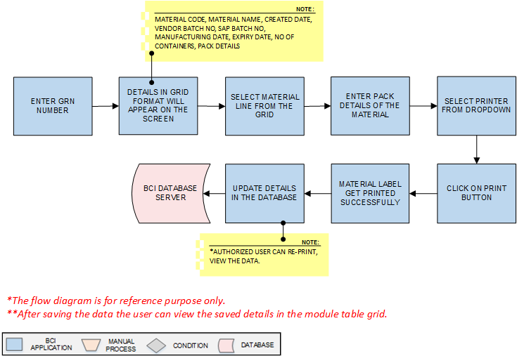
Material Label Printing
Activities
Module Description | The Module will be used to print material label for each container against GRN material details.

Pre-Conditions | - Material data should be saved in GRN number.  - Material Inspection needs to be completed.

Process Steps | - Enter GRN number.  - A grid format of Material Code, Material Name, Created Date, Vendor Batch No, SAP Batch No, Manufacturing Date, Expiry Date, No of Containers, Pack details, Done By will appear on the screen.  - Select checkbox of Material line from the list.  - Enter Pack Details of the material.  - Select printer from dropdown.  - Click on Print button.  - Material label get printed successfully.  - Data is saved in database.  *Authorized user can re-print, view the data.

Post-Conditions | - Material Label get printed.

Validations | - An alert should be displayed in case duplicate/ invalid GRN number is entered.

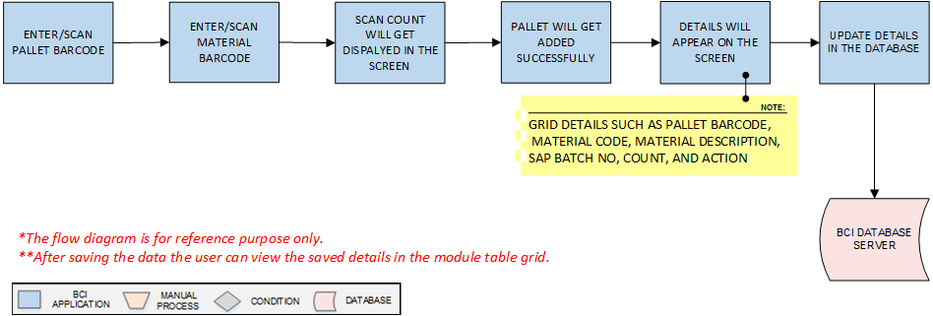
Palletization
Activities
Module Description | This module will be used to map pallet and material containers placed on pallet.

Pre-Conditions | - Printed labels are applied on each container.  - Pallet should have valid barcode.

Process Steps | - Enter/Scan Pallet Barcode.  - Enter/Scan Material Barcode.  - Scan count will get appear in the screen.  - Pallet will get added successfully.  - A grid format of Pallet details such as Pallet Barcode, Material Code, Material Description, SAP Batch No, Count, and Action will appear on the screen.  - Data is saved in database and display in grid.  - Grid view display as Created date, Pallet bar code, Material code, Material Name, SAP Batch No, No of Container, Done by and action.

Post-Conditions | - Pallet details are saved in database.  - Pallets are moved for Put away in warehouse.

Validations | - An alert should be displayed in case duplicate/ invalid Pallet Barcode is entered.  - An alert should be displayed in case duplicate/ invalid Material Barcode is entered.

Put Away
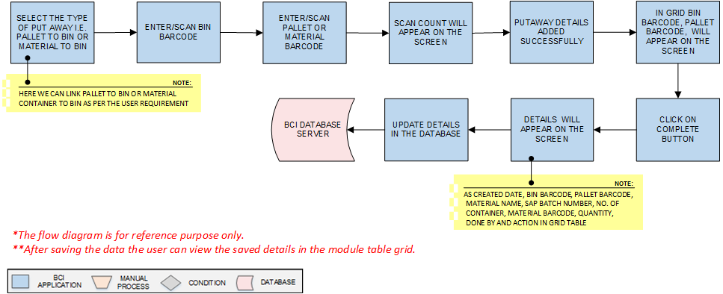
Activities
Module Description | This module will be used to map Pallets to Bins and Material to Bins.

Pre-Conditions | 1. In case of the Material to bin all the containers should contain bar code label  2.In case of pallet to bin all pallets should contain bar code label

Process Steps | - Select the type of Put Away i.e. Pallet to Bin or Material to Bin.  *Here we can link (Store) pallet to Bin or Material Container to Bin as per the user requirement.  - Enter/Scan Bin Barcode.  - Enter/Scan Pallet or Material Barcode.  - Scan count will appear on the screen.  - Put away details added successfully.  - A grid format of Bin Barcode and Pallet Barcode will appear on the screen  - Click on Complete Button.  - Data is saved in database and details in grid.  - Grid view display as created date, Bin barcode, Pallet barcode, Material Name, SAP Batch Number, No. of Container, Material Barcode, Quantity, Done by and Action.

Post-Conditions | - Pallet or Material Put Away is completed.

Validations | - An alert should be displayed in case duplicate/ invalid Bin Barcode is entered.  - An alert should be displayed in case duplicate/ invalid Pallet Barcode is entered.  - An alert should be displayed in case duplicate/ invalid Material Barcode is entered.

Bin To Bin Transfer
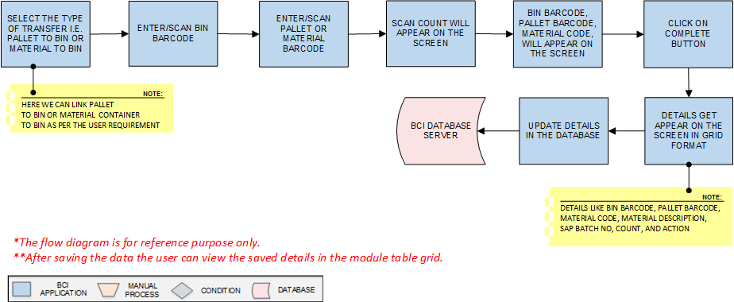
Activities
Module Description | This module will be used to transfer material or pallet from one bin to other.

Pre-Conditions | - Material already placed in Bin

Process Steps | - Select the type of transfer i.e. Pallet to Bin or Material to Bin.  - *Here we can link (Transfer) pallet to different Bin or Material Container to different Bin as per the user requirement  - Enter/Scan Bin Barcode.  - Enter/Scan Pallet or Material Barcode.  - Scan count will appear on the screen.  - grid format of Bin Barcode and Pallet Barcode will appear on the screen.  - Click on Complete Button.  - A grid format of Bin Barcode, Pallet Barcode, Material Code, Material Description, SAP Batch No, Count, and Action will appear on the screen.  - Data is saved in database.  - Selecting the back/cancel button user can return to the main grid screen from the particular screen without any change.

Post-Conditions | - Material are transferred from one bin to other bin.

Validations | - An alert should be displayed in case duplicate/ invalid Bin Barcode is entered.  - An alert should be displayed in case duplicate/ invalid Pallet Barcode is entered.  - An alert should be displayed in case duplicate/ invalid Material Barcode is entered.  - Allocated material can only be transferred.

GRN Cancellation
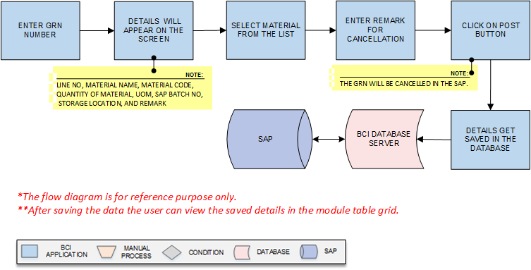
Activities
Module Description | This module will be used to cancel the posted GRN.

Pre-Conditions | - GRN posting is completed.

Process Steps | - Enter GRN number.  - A grid of Line No, Material Name, Material Code, Quantity of Material, UOM, SAP Batch No, Storage Location, and Remark will appear on the screen.  - Select checkbox of Material from the list.  - Enter Remark for cancellation for the selected material.  - Click on Post button.  *The GRN will be cancelled in the SAP.  - Details will get saved in database and display in grid view.  - The grid view as GRN NO, GRN Date, Purchase order/STO, Material code, Material Name, Invoice No, Invoice date, done by and action.  - By selecting the action details of the entry will be display.  - Selecting the back/cancel button user can return to the main grid screen from the particular screen without any change.

Post-Conditions | - GRN Posting is cancelled.

Validations | - An alert should be displayed in case duplicate/ invalid GRN No is entered.

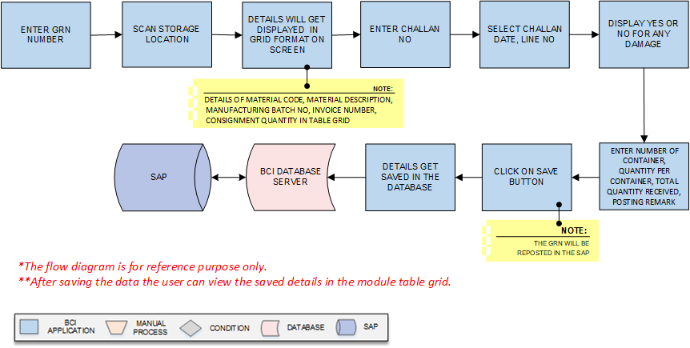
GRN RePosting
Activities
Module Description | This module will be used to repost the cancelled GRN.

Pre-Conditions | - GRN No should be available.

Process Steps | - Enter GRN number.  - Scan Storage Location.  - A grid format of Material Code, Material Description, Manufacturing Batch No, Invoice Number, Consignment Quantity will be displayed on the screen..  - Enter Challan No in the grid.  - Select Challan Date, Line No in the grid  - Display the Yes or No for any damage.  - Enter Number of Container, Quantity per Container, Total Quantity Received, Posting Remark.  - Click on save button.  *The GRN will be reposted in the SAP.  - Click on Close button to close reposting  - Data is saved in database.

Post-Conditions | - GRN is reposted.

Validations | - An alert should be displayed in case duplicate/ invalid GRN No is entered.  - An alert should be displayed in case duplicate/ invalid Storage Location is entered

Weighing Calibration
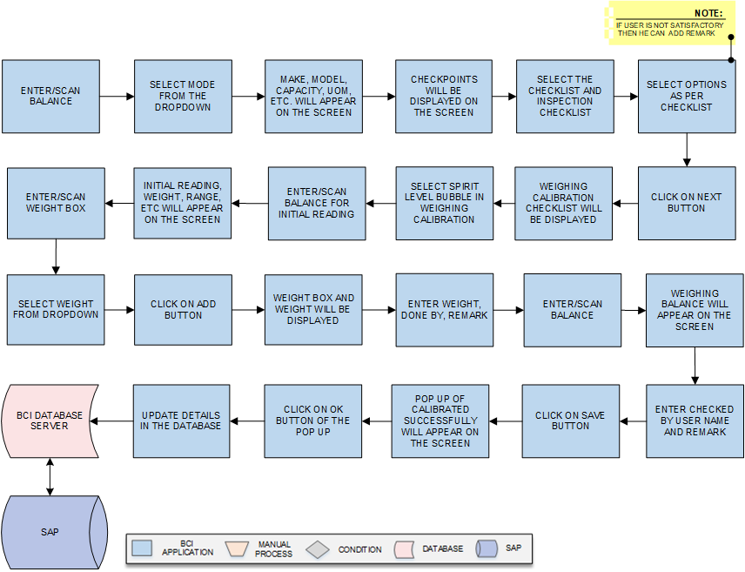

Activities
Module Description | This module will be used for weighing balance calibration and verification

Pre-Conditions | - Weighing Balance, Standard weight box, standard weight master should available.

Process Steps | - Enter/Scan Balance.  - Select Mode from the dropdown.  - Make, Model, Capacity, Unit of Measurement, Least Count, Reference SOP No, Format No, and Version will appear on the screen.  - Checkpoints will be displayed on the screen.  - Select the Checklist type and Inspection Checklist from the dropdown.  - Select options as per checklist.  *If user is not satisfactory then he can add remark & system should not proceed further in case of abnormal observation.  - Click on Next button.  - Weighing Calibration checklist will be displayed  - Select Spirit level checkbox in Weighing Calibration.  - Enter/Scan balance for initial reading.  - Initial reading, Calibration Level, Weight, Range will appear on the screen.  - Enter/Scan Weight Box.  - Select Weight from dropdown.  - Click on Add button.  - A grid format of Weight Box and Weight will be displayed on the screen.  - Enter Weight, Done By, Remark.  - Enter/Scan Balance.  - Weighing Balance will appear on the screen.  - Enter Checked By user name and Remark  - Click on Save button.  - If all the results are satisfactory as per the master then Pop up of Weighing Machine Calibrated Successfully will appear on the screen.  - Data is saved in database.

Post-Conditions | - Weighing machine calibration and Verification is completed.

Validations | - An alert should be displayed in case of invalid Balance is scanned.  - An alert should be displayed in case of invalid Mode and Weight is selected.  - An alert should be displayed in case of invalid Weight Box is scanned.  - An alert should be displayed in case of Initial reading will not set to zero.

Sampling

Cubicle Assignment
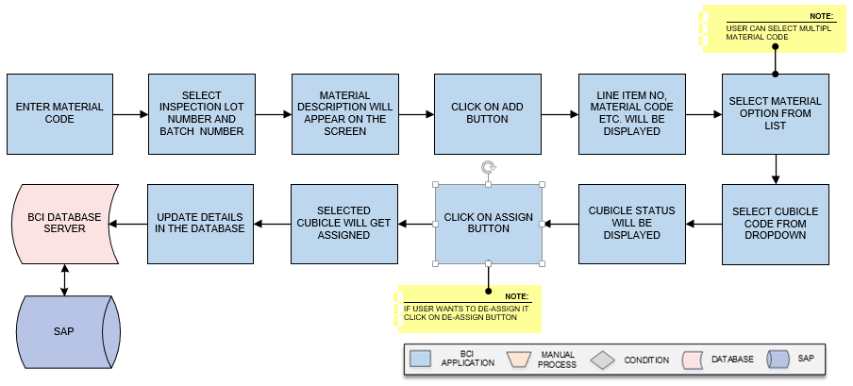
Activities
Module Description | This module will be used to assign cubicle for sampling of Raw material and Packing material against the Inspection Lot/A.R.No.

Pre-Conditions | - Inspection Lot details needs to be imported from SAP.

Process Steps | - Enter the Material Code.  - Select the Inspection Lot Number, Batch Number from the dropdown list.  - Material Description and other details will be appear on the screen.  - Click on Add button.  - A grid format of, Line Item No, Cubicle id, Material Code, Product Description, SAP Batch No, Quantity, UOM, Expiry Date, Retest Date, and Inspection Lot No will be displayed on the screen.  - User will select checkbox of the Material from the list for which assignment is needed (If required).  - Select the Cubicle Code from dropdown; in which the material is to be assigned for sampling.  - Cubicle Status for the material will be displayed.  - Then click on Assign button.  *Incase user wants to de-assign cubicle, select the material line from the list and click on De-Assign button.  - The group code gets assigned for inspection lot number to the selected materials.  - Data gets updated in database.

Post-Conditions | - Further process of sampling will be proceed.

Validations | - While creating group, system will validate material details data is imported from SAP.  - While assigning cubicle, system will validate whether the material SAB batch no. is not already assigned to other cubicle.  - An alert will be displayed in case of invalid Material Code is entered.

Cubicle Cleaning
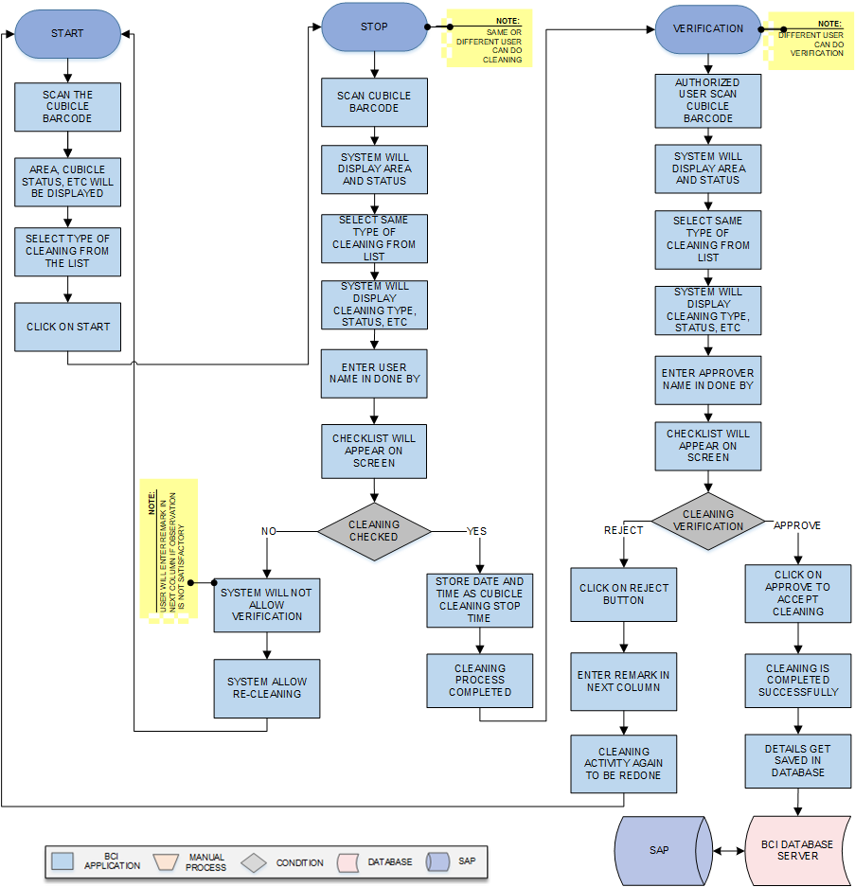
Activities
Module Description | This module will be used for Cubicle cleaning process.

Pre-Conditions | - Cubicle status can be clean/unclean/not in use in system.

Process Steps | 1. Cleaning  - Cleaning Start: - User will scan Cubicle Barcode which is applied on cubicle door.  - Area and Cubicle Status, Previous SAP Batch No, Previous Material Code, will be displayed on the screen.  - Select the type of cleaning from the dropdown list.  - Then click on Start button, system store as start time in database against the cubicle.  - The Cubicle Cleaning added successfully message appears on bottom.  - Cleaning Stop: - After cleaning procedure scan the Cubicle Barcode.  - Selected Area and Cubicle Status will be displayed on the screen along with the previous SAP batch No, previous material code.  - Select the same type of cleaning used for start from the dropdown list.  *Same Type will be selected as start process.  - System will display Cleaning Type, Status, Date & Time and Action Taken by user details in the table grid.  - Enter cleaning done by person name.  - Checkpoints will be displayed on the screen.  - User will verify the cleaning and update observations in the checklist  - After completing the check list, user will click on Stop button.  - System will store date and time as cubicle cleaning stop time.  - Cubicle has been cleaned stopped successfully notification will appear on the screen.  - If cleaning is not satisfactory as per the checkpoints, user to enter the remark in the remark column.  - Verification:  - Authorize user will scan the Cubicle Barcode.  - Area, Previous Material Code, Previous SAP Batch No, Cubicle Status will be displayed on the screen.  - Select Type of cleaning from dropdown.  *The type should be same as Start and Stop process.  - System will display Cleaning Type, Status, Date & Time, Action Taken By in the table grid.  - Checkpoints will be displayed on the screen.  - Click on Is Verified Checkbox.  - User will click on Approve or Reject and enter the remark.  - After rejection cubical cleaning system should allow re-cleaning of the cubicles  - Click on Clear to clear all the details in the fields.  - Click on Close to close the current cleaning window.  - Data gets updated in the database

Post-Conditions | - Cubicle status will be changed to clean

Validations | - Sequence of cleaning will be followed as Cleaning Start, Cleaning Stop and Verification  - An error message will be displayed in case of different cleaning type is selected.

Equipment Cleaning
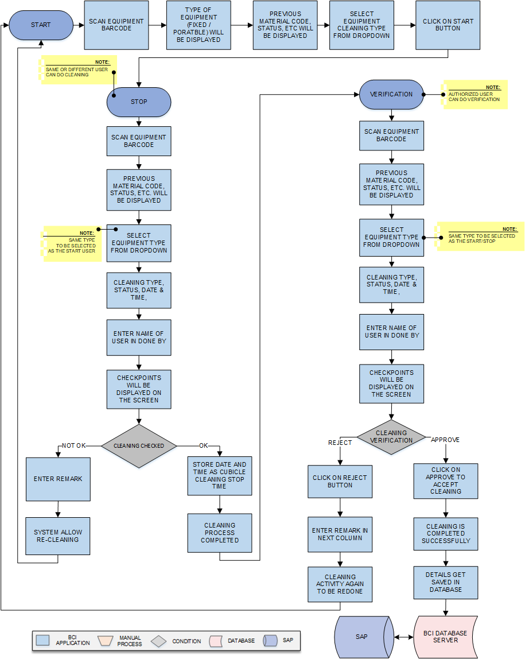

Activities
Module Description | This module will be used for Equipment cleaning process.

Pre-Conditions | - Equipment status should be unclean and not in use in system.

Process Steps | Equipment cleaning will be done in 2 steps.  - Cleaning  - Cleaning Start: - User will scan Equipment Barcode which is applied on Equipment.  - Equipment type (fixed/portable), Previous Material Code, Previous SAP Batch No, Area Barcode, Status and other details will be displayed.  - Select the Equipment Cleaning Type from the dropdown list.  - Then click on Start button, system store current as start time in database against the equipment.  - Cleaning Stop: - User will scan Equipment Barcode.  *Same or other person can do the stop process.  - Previous Material Code, Previous SAP Batch No, Area Barcode, Status and other details will be displayed on the screen.  - Select the Equipment Cleaning Type from the dropdown list.  *Same type to be selected as the start process.  - System will display Cleaning Type, Status, Date & Time, Action Taken By  - Enter the name of the person cleaning done by.  - Checkpoints will be displayed on the screen.  - User will verify the checkpoints and update the observations in case of any non-conformance compulsory remark will be enter.  - After completing the check list, user will click on Stop button.  - System will store current date and time as cubicle cleaning stop time.  - Equipment has been cleaned stopped notification will appear on the screen.  - Verification:  - Authorized user will scan Equipment Barcode.  - Previous Material Code, Previous SAP Batch No, Area Barcode, Status and other details will be displayed on the screen.  - Select the Equipment Cleaning Type from the dropdown list.  *Same type to be selected as the start and stop process.  - System will display Cleaning Type, Status, Date & Time, and Action Taken By in grid format.  - Checkpoints will be displayed on the screen.  - Click on Is Verified Checkbox if Cleaning found satisfactory.  - User will click Approve or Reject based on observation and enter remark.  - System should allow to re-clean the equipment in case of Rejection and do not allow to proceed next steps.  - Click on Clear to clear all the details in the fields.  - Click on Close to close the current cleaning window.  - Data gets updated in the database and SAP.

Post-Conditions | - Equipment assignment will be done.

Validations | - Sequence of cleaning will be followed as Equipment Cleaning Start, Equipment Cleaning Stop and Equipment Cleaning Verification  - An error message will be displayed in case of different cleaning type is selected.

Equipment Assignment
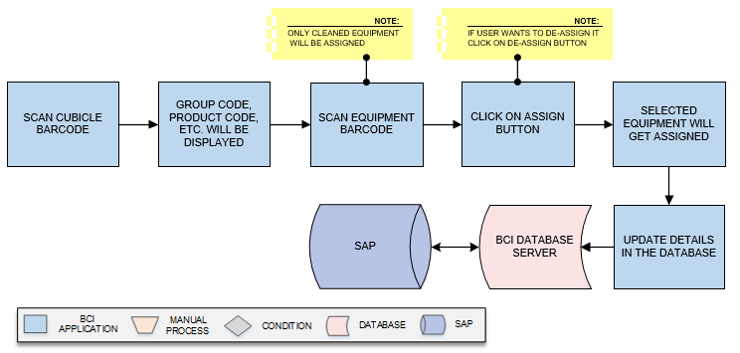
Activities
Module Description | This module will be used for Equipment assigning process.

Pre-Conditions | - Equipment status should be clean in system.

Process Steps | - User will scan Cubicle Barcode in which equipment is placed.  - The Group code, Product code, Product Description and SAP Batch Number will displayed on the screen.  - User will scan Equipment Barcode which is applied on Equipment.  *Only cleaned equipment can be assigned.  - Click on Assign button, the equipment gets assigned to that cubicle.  - For de-assign of the equipment’s  *User will click on De-Assign button, to de-assign the equipment as per requirement.  - Click on Clear to clear all the details in the fields.  - Click on Close to close the current cleaning window.  - Save the details in database.

Post-Conditions | - Equipment will be assigned to the cubicle.

Validations | - Unclean equipment should not allowed for the assignment.  - Alert message will be displayed in case of invalid Cubicle Barcode is entered.  - Alert message will be displayed in case of invalid Equipment Barcode is entered.

Line Clearance
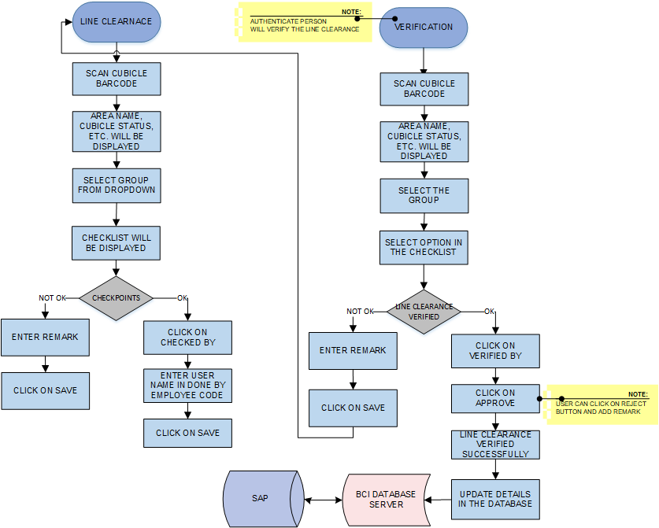
Activities
Module Description | This module will be used for line clearance.

Pre-Conditions | - Cubicle and equipment status should be clean in system.

Process Steps | - Line Clearance  - Scan the Cubicle Barcode.  - Area Name, Previous Material Code, Previous SAP Batch No, Cubicle status will be displayed for the cubicle.  - Select the Group from the dropdown list.  - Checkpoints will be displayed on the screen.  - User will check the points as per the checklist and update observation details .  - Enter the employee code of the done by person system will display name of the person from system data base.  - Click on Checked by checkbox system will update checked by details as per the current user details.  - In case Line clearance verification done on same screen:-.  *On same screen, Authorized person will select Verified By and login with his credentials. System will store date, time and login user id. Line clearance will be approved successfully on the same system by authorize user. If anything is found non satisfactory then user will click on Reject button.  - Line clearance added successfully notification will appear on the screen.  - Verification (In case by log in from different system)  - Scan the Cubicle barcode.  - Select the Group from the dropdown list.  - Area Name, Previous Material Name, Previous SAP Batch No, Cubicle status will be displayed for the cubicle System will be displayed  - checkpoints selected while line clearance  - Then click on Approve button.  - The Line clearance approved successfully message pop up.  *If anything is found non satisfactory then user will click on Reject button and enter remark.  - Data gets updated into the database.  Line clearance not required for the packing materials , Picking& Pre-staging activity can be performed before line clearance

Post-Conditions | - Line clearance will be completed.

Validations | - An alert should be displayed in case duplicate/ invalid Cubicle Barcode is entered.  - An alert should be displayed in case duplicate/ invalid Cubicle Group is selected

Picking
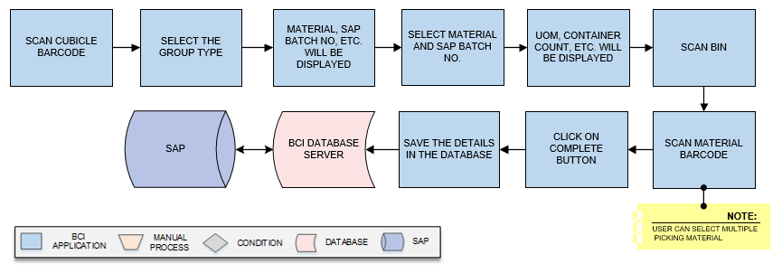
Activities
Module Description | The Module will be used to Pick material from Location and place in Pre stage area.

Pre-Conditions | - Group needs to be created.  - Material is allocated in location.

Process Steps | - Scan the Cubicle Barcode.  - User will select the Group from the dropdown list.  - A grid format of Material code, material name, SAP Batch No, Suggested Bin will appear on the screen.  - Select Material and SAP Batch No. from drop down list.  - UOM, Suggested Bin, Scan Bin Previous quantity, Container Count, Quantity, Picking Status, Last Scan will be displayed on the screen.  - Scan Material Barcode.  - After scanning of the container last scanned, quantity , container county will display and picking status will be updated  *User can select multiple picking material containers  - Click on Complete button.  - User will click on Clear button to clear the data.  - User will click on Close button to close the picking.  - Data gets updated in the database

Post-Conditions | - Material will be placed in Pre Stage area.

Validations | - An alert should be displayed in case duplicate/ invalid Cubicle Barcode is entered.  - An alert should be displayed in case duplicate/ invalid Group is selected  - An alert should be displayed in case duplicate/ invalid Material is selected.  - An alert should be displayed in case duplicate/ invalid Bin is entered.  - An alert should be displayed in case duplicate/ invalid Material Barcode is entered.

Pre Staging
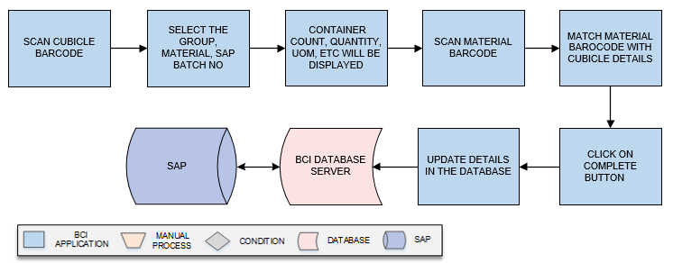
Activities
Module Description | This module will be used to validate material movement from pre staging area to staging.

Pre-Conditions | - Material Picking is completed

Process Steps | - Scan the Cubicle barcode.  - Select the Group, Material a grid view of material and SAP batch no will display.  - Select material and SAP batch no from the drop down  - System will display the Container Count, Quantity, UOM and Status. for which picking is completed  - Scan Material Barcode.  - Data will display in UOM, container count, quantity and status  - Click on Complete to successfully approve the pre-stage process.  - User will click on Clear button to clear the data.  - User will click on Close button to close the Pre staging.  - System will updated as status as material pre staged.  - Data gets updated in the database and SAP.

Post-Conditions | - Perform staging
Validations | - An alert should be displayed in case duplicate/ invalid Cubicle Barcode is entered.  - An alert should be displayed in case duplicate/ invalid Group is selected  - An alert should be displayed in case duplicate/ invalid Material Barcode is entered.

Staging
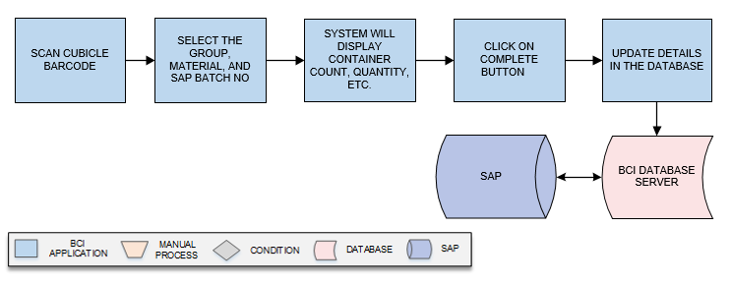
Activities
Module Description | This module will be used to validate material movement from staging area to Sampling.

Pre-Conditions | - Material pre-staging Picking is completed.  - Line clearance should completed

Process Steps | - Scan the Cubicle Barcode.  - Select the Group.  - Grid view of the Material and SAP batch no will display.  - Select Material, and SAP Batch No from the dropdown list.  - System will display the Container Count, Quantity, UOM, and Status. for which picking is completed  - Scan the material bar code , data will display in UOM, Container count, Quantity , last scanned and status--  - Click on Complete to approve the staging.  - User will click on Clear button to clear the data.  - User will click on Close button to close the Pre staging.  - System will updated as status as material approved of staging.  - Data gets updated in database .

Post-Conditions | - Ready to perform Sampling

Validations | - An alert should be displayed in case duplicate/ invalid Cubicle Barcode is entered.  - An alert should be displayed in case duplicate/ invalid Group is selected  - An alert should be displayed in case duplicate/ invalid Material is selected.  - Only presaged material can be scanned in Staging.

Sampling
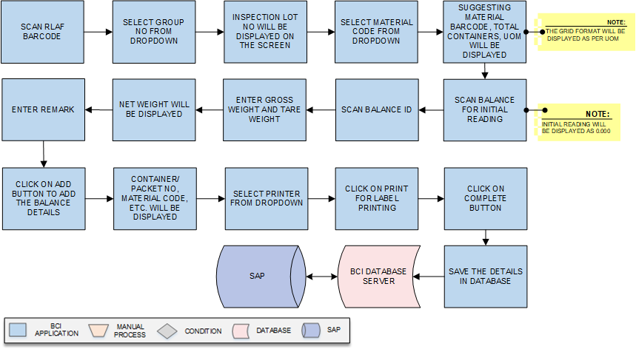
Activities
Module Description | This module will be used to sampling of the material material

Pre-Conditions | - Staging of the material is completed.

Process Steps | - Scan the RLAF Barcode.  - Select Group Code from dropdown.  - Inspection Lot No will be displayed on the screen.  - Select Material Code and SAP batch no. from dropdown.  - Suggesting Material Barcode, Total Containers will be displayed on the screen  - UOM will be displayed on the screen.  Based on the UOM (KG & No) further screen will be display.  - For the Material of which UOM is KG: -  - Scan Balance for initial reading in Balances section.  *Initial reading will be displayed as 0.000.  - Scan Balance Id.  - Enter Gross weight and Tare weight.  - Net weight will be displayed on the screen after auto calculation by the system.  - Enter Remark.  - Click on Add button to add the Balance details.  - A grid format of Container/Packet No, Material Code, SAP Batch No, Sample Quantity, UOM, Done By, Remark, Action will be displayed on the screen.  - Select the printer from the dropdown list.  - Then click on Print button then the label will be printed.  - After completing sampling for that material, user will click on Complete button, system will note the process for sampling.  - User will click on Clear button to clear the data.  - User will click on Close button to close the Sampling.  - Data gets updated in the database and SAP.

Post-Conditions | - Sampled label will be generated.

Validations | - An alert should be displayed in case duplicate/ invalid RLAF is entered.  - An alert should be displayed in case duplicate/ invalid Group Code is selected  - An alert should be displayed in case duplicate/ invalid Material Code is selected.

Stage Out
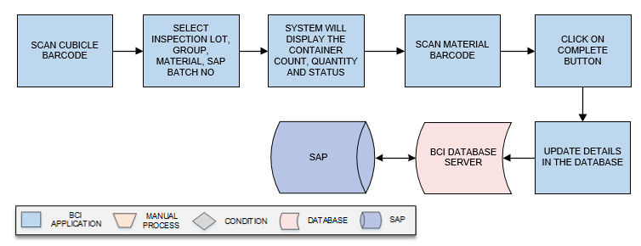
Activities
Module Description | This module will be used stage out the Material from cubicle.

Pre-Conditions | - Sampling should be completed

Process Steps | - Scan the Cubicle Barcode.  - Select Inspection Lot, Material, SAP Batch No from the dropdown list.  - System will display the Container Count, Quantity and Status. for which stage out is required  - Scan Material Barcode for loose material which is to be reallocated details will be updated as per material.  - Click on Complete button.  - User will click on Clear button to clear the data.  - User will click on Close button to close the Stage Out.  - Data gets updated in the database and SAP.

Post-Conditions | - Container will be removed from the cubicle.

Validations | - An alert should be displayed in case duplicate/ invalid Cubicle Barcode is entered  - An alert should be displayed in case duplicate/ invalid Material Barcode is entered.

Putaway
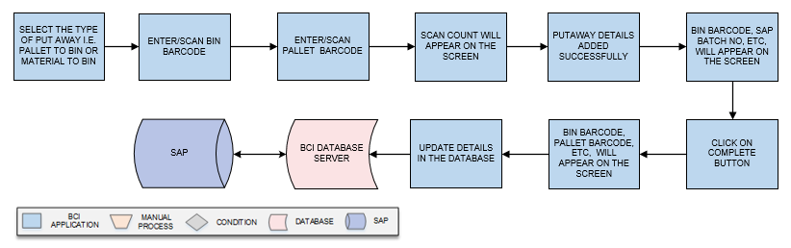
Activities
Module Description | This module will be used to map sample materials in Pallets to Bins and Material to Bins.

Pre-Conditions | - Stage out should be completed.

Process Steps | - Select the type of Put Away i.e. Pallet to Bin or Material to Bin.  *Here we consider Pallet to Bin putaway. Same process will be applied for Material to Bin putaway.  - Enter/Scan Bin Barcode.  - Enter/Scan Pallet Barcode.  - Scan count will appear on the screen.  - Putaway details added successfully.  - A grid format of Bin Barcode, Material Code, SAP Batch No, Container Serial No, Material Barcode, Quantity will appear on the screen.  - Click on Complete Button.  - A grid format of Bin Barcode, Pallet Barcode, Material Code, Material Description, SAP Batch No, Count, and Action will appear on the screen.  - Data is saved in the database and SAP.

Post-Conditions | - Pallet or Material Put Away is completed.

Validations | - An alert should be displayed in case duplicate/ invalid Bin Barcode is entered.  - An alert should be displayed in case duplicate/ invalid Pallet Barcode is entered.  - An alert should be displayed in case duplicate/ invalid Material Barcode is entered.

Dispensing

Cubicle Assignment
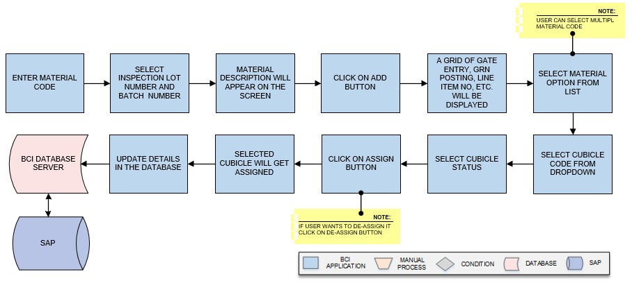
Activities
Module Description | This module will be used to assign cubicle for dispensing of Raw material and Packing material against the process order/Reservation number..

Pre-Conditions | - Process Order/Reservation Number details should be imported from SAP.

Process Steps | - Enter the Material Code.  - Select the Inspection Lot Number, Batch Number from the dropdown list.  - Material Description and other details will be appear on the screen.  - Click on Add button.  - A grid format of, Line Item No, Cubicle id, Material Code, Product Description, SAP Batch No, Quantity, UOM, Expiry Date, Retest Date, and Inspection Lot No will be displayed on the screen.  - User will select checkbox of the Material from the list for which assignment is needed.  *User can select multiple material from the list.  - Select the Cubicle Code from dropdown; in which the material is to be assigned for sampling.  - Cubical Status for the material will be displayed.  - Then click on Assign button.  *Incase user wants to de-assign cubicle, select the material from the list and click on De-Assign button.  - The group code gets assigned for inspection lot number to the selected materials.  Data gets updated in database and SAP.

Post-Conditions | - Cubicle assignment is completed.

Validations | - An alert should be displayed in case duplicate/ invalid Process Order/Reservation number is selected.  - An alert should be displayed in case of duplicate/invalid Material Code is selected.  - An alert should be displayed in case of duplicate/invalid Cubicle barcode is selected.

Cubicle Cleaning

Activities
Module Description | This module will be used for Cubicle cleaning process

Pre-Conditions | - Cubicle status should be unclean in system.  - Cubicle assignment should be completed.

Process Steps | Cleaning start process:  While starting the cleaning of cubicle user will scan Cubicle Barcode and update start time in system using Mobile device.  1. Cleaning  - Cleaning Start :- User will scan Cubicle Barcode which is applied on cubicle door.  - Area and Cubicle Status, Previous product name, Previous batch no and cubicle status will be displayed on the screen.  - Select the cleaning type from the dropdown list.  - Then click on Start button, system store as start time in database against the cubicle.  - The Cubical Cleaning added successfully message appears on bottom.  - Cleaning Stop:-Scan the Cubicle Barcode.  - Area and Cubicle Status will be displayed on the screen.  - Select the same type used for start from the dropdown list.  *Same Type will be selected as start process.  - System will display Cleaning Type, Status, Date & Time and Action Taken by user details in the table grid.  - Enter cleaning done by person name.  - Update the check points as per the observation, in case of the nonconformance observation remark required.  - After completing the check list, user will click on Stop button.  - System will store date and time as cubicle cleaning stop time.  - Cubicle has been cleaned stop successfully notification will appear on the screen.  - Verification:  - Authorize user will scan the Cubicle Barcode.  - Area, Previous product name, Previous Batch No, Cubicle Status will be displayed on the screen.  - Select Type from dropdown.  *The type should be same as Start and Stop process.  - System will display Cleaning Type, Status, Date & Time, Action Taken By in the table grid.  - Checkpoints will be displayed on the screen.  - Click on Is Verified Checkbox.  - User will click on Approve or Reject and update the remark.  *if user click on Reject then user will enter remark.  - After rejection system should allow to re-clean the cubicle  - Click on Clear to clear all the details in the fields.  - Click on Close to close the current cleaning window.  Data gets updated in the database .

Post-Conditions | - Cubicle cleaning of Process Order is completed.

Validations | - An alert should be displayed in case duplicate/ invalid Cubicle Barcode is selected.  - An error message will be displayed in case of different cleaning type is selected.

Equipment Cleaning

Activities
Module Description | This module will be used for Equipment cleaning process

Pre-Conditions | - Equipment status should be unclean in system.

Process Steps | Equipment cleaning will be done in 2 steps.  - Cleaning  - Cleaning Start :- User will scan Equipment Barcode which is applied on Equipment.  - Equipment type (fixed/portable), Previous product name, Previous Batch No, Area Barcode, Status and other details will be displayed.  - Select the Equipment Cleaning Type from the dropdown list.  - Then click on Start button, system store as start time in database against the equipment.  - User will scan Equipment Barcode which is applied on Equipment.  *Same person who started the cleaning or other authorized person can stop equipment cleaning  - Cleaning Stop: - Previous Product name, Previous Batch No, Area Barcode, Status and other details will be displayed on the screen.  - Select the Equipment Cleaning Type from the dropdown list.  *Same type to be selected as the start process.  - System will display Cleaning Type, Status, Date & Time, Action Taken By  - Enter name of user in Done by textfield.  - Checkpoints will be displayed on the screen..  - User will check then user will enter remark in next column.  - After completing the check list, user will click on Stop button.  - System will store date and time as cubicle cleaning Stop time.  - Equipment has been cleaned successfully notification will appear on the screen.  - Verification:  - Authorized user will scan Equipment Barcode.  - Previous Material Code, Previous SAP Batch No, Area Barcode, Status and other details will be displayed on the screen.  - Select the Equipment Cleaning Type from the dropdown list.  *Same type to be selected as the start and stop process.  - System will display Cleaning Type, Status, Date & Time, Action Taken By in grid format.  - Checkpoints will be displayed on the screen.  - User will check then user will enter remark in next column.  - Click on Is Verified Checkbox.  - Enter Approval/Rejection Description  - User will click Approve or Reject.  *If user click on Reject then user will enter remark in next column.  - After rejection cubical cleaning activity again to be redone by start user.  - Select Is Verified check box to get the cleaning process verified.  - Click on Approve to accept the cleaning activity as completed.  - Click on Clear to clear all the details in the fields.  - Click on Close to close the current cleaning window.  - Data gets updated in the database and SAP.

Post-Conditions | - Equipment cleaning of cubicle against process order is completed.

Validations | - An alert should be displayed in case duplicate/ invalid Cubicle Barcode is selected.  - Sequence of cleaning will be followed as Cleaning Start, Cleaning Stop, and Verification.  - An error message will be displayed in case of different cleaning type is selected.

Equipment Assignment
Activities
Module Description | This module will be used for Equipment assignment.

Pre-Conditions | - Equipment status should be unclean in system.

Process Steps | - User will scan Cubical Barcode in which equipment is placed.  - The Group code, Product code, Product Description and SAP Batch Number and other details will displayed on the screen.  - User will scan Equipment Barcode which is applied on Equipment.  *Only cleaned equipment will be assigned.  - Click on Assign button, the equipment gets assigned to that cubicle.  *User will click on De-Assign button, to de-assign the equipment to that cubicle.  - Selected equipment will be assigned.  - Click on Clear to clear all the details in the fields.  - Click on Close to close the current cleaning window.  - Save the details in database

Post-Conditions | - Equipment will be assigned to the cubicle.

Validations | - Unclean equipment should not allowed for the assignment

Line Clearance
Activities
Module Description | This module will be used for Line Clearance of cubicle against process order.

Pre-Conditions | - Cubicle Cleaning should be completed.

Process Steps | - Line Clearance  User will perform line clearance check list in Pharmision device application  - Scan the Cubicle Barcode.  - Area Name, Previous Material Name, Previous SAP Batch No, Cubicle status will be displayed for the cubicle.  - Select the Group from the dropdown list.  - Checkpoints will be displayed on the screen.  - User will check then user will enter remark in next column if he is not satisfactory.  - Click on Checked by checkbox.  - Enter user name in Done By Employee Code  - Click on Save button.  *On same system, Authorized person will select Verified By and login with his credentials. System will store date, time and login user id. Line clearance will be approved successfully on the same system by authorize user. If anything is found non satisfactory then user will click on Reject button.  - Line clearance added successfully notification will appear on the screen.  - Verification  - Scan the Cubicle barcode.  - Select the Group from the dropdown list.  - Area Name, Previous Material Name, Previous SAP Batch No, Cubicle status will be displayed for the cubicle System will be displayed  - checkpoints selected while line clearance  - User will check as then user will enter remark in next column.  - Then click on Approve button.  - The Line clearance approved successfully message pop up.  *If anything is found non satisfactory then user will click on Reject button and enter remark.  - Data gets updated into the database and SAP.

Post-Conditions | - Line clearance will be completed.

Validations | - An alert should be displayed in case duplicate/ invalid Cubicle Barcode is selected.  - Scanning of cubicle barcode will be allowed for which Cubicle cleaning completed for Line clearance.  - Once line clearance is done then only verification can be performed.  - If activity is not accepted by checked by or verified by then again Re-line- clearance needs to be performed.

Picking
Activities
Module Description | The Module will be used to Picking material from Bin Location and place in Pre stage area.

Pre-Conditions | - Group should be created.  - Material should be allocated in Bin location.

Process Steps | - Scan the Cubicle Barcode.  - User will select the Group from the dropdown list.  - A grid format of Material code , SAP Batch No, and Suggested Bin will appear on the screen.  - Select Material and SAP Batch No. from drop down list.  - UOM, Suggested Bin, Previous quantity, Container Count, Quantity, Picking Status, Last Scan will be displayed on the screen.  - Scan Bin.  - Scan Material Barcode.  *User can select multiple picking material.  - Click on Complete button.  - User will click on Clear button to clear the data.  - User will click on Close button to close the picking.  - Data gets updated in the database and SAP.

Post-Conditions | - Material is placed in Pre Stage area.

Validations | - An alert should be displayed in case duplicate/ invalid Cubicle Barcode is entered.  - An alert should be displayed in case duplicate/ invalid Group is selected  - An alert should be displayed in case duplicate/ invalid Material is selected.  - An alert should be displayed in case duplicate/ invalid Bin is entered.  - An alert should be displayed in case duplicate/ invalid Material Barcode is entered.

Pre Stage
Activities
Module Description | This module will be used to validate material movement from pre staging area to Dispensing.

Pre-Conditions | - Material Picking should be completed.

Process Steps | - Scan the Cubicle barcode.  - Select the Group, Material, SAP Batch No from the dropdown list.  - System will display the Container Count, Quantity, UOM and Status. for which picking is completed  - Scan Material Barcode.  - Click on Complete to successfully approve the pre-stage process.  - User will click on Clear button to clear the data.  - User will click on Close button to close the Pre staging.  - System will updated as status as material pre staged.  Data gets updated in the database and SAP.

Post-Conditions | - Perform staging.

Validations | - An alert should be displayed in case duplicate/ invalid Material Barcode is selected.  - An alert should be displayed in case duplicate/ invalid Cubicle Barcode is entered.  - An alert should be displayed in case duplicate/ invalid Group is selected

Staging
Activities
Module Description | This module will be used to validate material movement from staging area to Dispensing booth.

Pre-Conditions | - Material Picking is completed and  - Line of Cubicle/Material to be completed.

Process Steps | - Scan the Cubicle Barcode.  - Select the Group, Material, and SAP Batch No from the dropdown list.  - System will display the Container Count, Quantity, UOM, and Status. for which picking is completed  - Click on Complete to approve the staging.  - User will click on Clear button to clear the data.  - User will click on Close button to close the Pre staging.  - System will updated as status as material approved of staging.  Data gets updated in database and SAP.

Post-Conditions | - Perform Dispensing.

Validations | - An alert should be displayed in case duplicate/ invalid Cubicle Barcode is entered.  - An alert should be displayed in case duplicate/ invalid Group is selected  - An alert should be displayed in case duplicate/ invalid Material is selected.  - Only pre staged material can be scanned in Staging.

Dispensing
Activities
Module Description | This module will be used to Dispensed material

Pre-Conditions | - Staging of the material should be completed.

Process Steps | - Scan the RLAF Barcode.  - Select Process Order No/Reservation No.  - A grid format of ‘Action, Line no, Process order no, Product Code, Product Description, Material Code, Material Description, SAP Batch No, Product batch no, Required quantity, UOM, Available Stock, Expiry Date will appear on the screen.  - Select checkbox of the material from the list  - Material details such as Material Barcode, SAP Batch No, Available Qty, UOM, Process Order No, Group Code will be displayed in grid format.  *Above grid will be displayed for kg. It will be varies as per UOM.  - Scan Material Barcode for which dispensing is needed.  - Scan Balance for initial reading.  *Initial reading will be displayed as zero.  - Scan Balance Id.  - Enter Gross weight and Tare weight.  - Net weight and status will be displayed on the screen  - Select printer from dropdown.  - Click on Add button  - Click on Issued By checkbox.  - Click on Checked by Checkbox  - A login screen for authorized person will appear on the screen.  - A grid format of Material Barcode, Group Code, Product Code, Product Name, Product Batch No, Material Description, SAP Batch No, Gross weight, Tare Weight, Net Weight will be displayed.  - After successful login of authorized person, click on complete button  - Dispensing completed successfully.  - Details get saved in database.  - User will click on Clear button to clear the data.  - User will click on Close button to close the Sampling.  - Data gets updated in the database and SAP.

Post-Conditions | - Dispensed label will be generated.

Validations | - An alert should be displayed in case duplicate/ invalid RLAF is entered.  - An alert should be displayed in case duplicate/ invalid PO No is selected.

Palletization
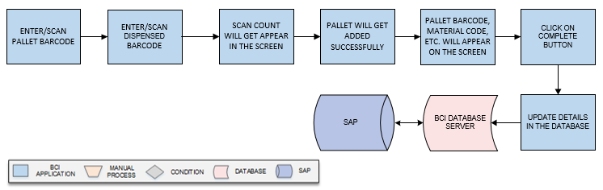
Activities
Module Description | This module will be used to map pallet and material containers placed on pallet.

Pre-Conditions | - Dispensing of material should be completed.  - Pallet should have barcode.

Process Steps | - Enter/Scan Pallet Barcode.  - Enter/Scan Dispensed Barcode.  - Scan count will get appear in the screen.  - Pallet will get added successfully.  - A grid format of Pallet details such as Pallet Barcode, Material Code, Material Description, Dispensed Barcode, SAP Batch No will appear on the screen.  - Click on Complete button.  - Data is saved in database.  *Authorized user can edit, view the data.

Post-Conditions | - Pallet details are saved in database.

Validations | - An alert should be displayed in case duplicate/ invalid Pallet Barcode is entered.  - An alert should be displayed in case duplicate/ invalid Material Barcode is entered.

Issue to Production
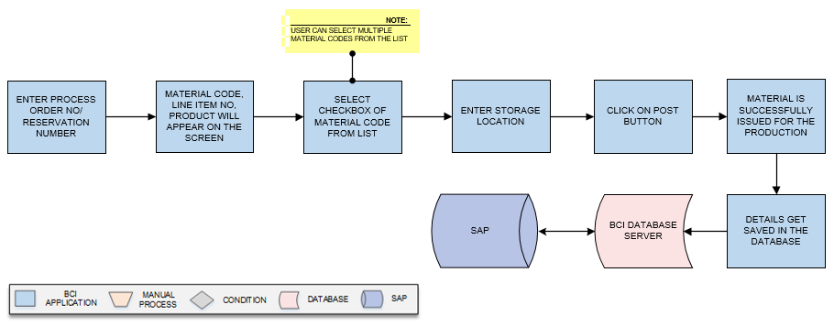
Activities
Module Description | This module is used to issue the material for the production (stock reduction from the SAP).

Pre-Conditions | - Dispensing should be completed.

Process Steps | - Enter Process Order No/Reservation Number.  - A grid format of Material Code, Material Description, Line Item No, Product, Product Batch No, SAP Batch No, AR No, Dispensed Qty, Base UOM, Storage Location, and Material Issue Note No will appear on the screen.  - Select checkbox of Material Code from list that need to send for production.  *User can select multiple Material Codes from the list.  - Enter Storage Location for the selected Material Code.  - Click on Post button.  - User can click on Close button to close the grid.  - Material Issue Note No will appear on the screen.  *Material Issue Note No will be generated and fetched from SAP.  - Material is successfully issued for the production.  - Details get saved in database.

Post-Conditions | - Material is issued for the production.  - Stock is redacted from SAP.

Validations | - An alert massage should be displayed in case duplicate/ invalid Process Order No is entered.

Stage Out
Activities
Module Description | This module will be used stage out Material from cubicle.

Pre-Conditions | - Dispensing is completed.

Process Steps | - Scan the Cubicle Barcode.  - Select Inspection Lot, Material, SAP Batch No from the dropdown list.  - System will display the Container Count, Quantity and Status. for which stage out is required  - Scan Material Barcode for loose material which is to be reallocated.  - Click on Complete button.  - User will click on Clear button to clear the data.  - User will click on Close button to close the Stage Out.  Data gets updated in the database and SAP

Post-Conditions | - Container will be removed from the cubicle.

Validations | - An alert should be displayed in case duplicate/ invalid Cubicle Barcode is entered  - An alert should be displayed in case duplicate/ invalid Material Barcode is entered.

Put Away
Activities
Module Description | This module will be used to map Pallets to Bins and Material to Bins.

Pre-Conditions | - Stage out should be completed.

Process Steps | - Select the type of Put Away i.e. Pallet to Bin or Material to Bin.  *Here we consider Pallet to Bin putaway. Same process will be applied for Material to Bin putaway.  - Enter/Scan Bin Barcode.  - Enter/Scan Pallet Barcode.  - Scan count will appear on the screen.  - Putaway details added successfully.  - A grid format of Bin Barcode, Material Code, SAP Batch No, Container Serial No, Material Barcode, and Quantity will appear on the screen.  - Click on Complete Button.  - A grid format of Bin Barcode, Pallet Barcode, Material Code, Material Description, SAP Batch No, Count, and Action will appear on the screen.  - Data is saved in the database and SAP.

Post-Conditions | - Pallet or Material Put Away is completed.

Validations | - An alert should be displayed in case duplicate/ invalid Bin Barcode is entered.  - An alert should be displayed in case duplicate/ invalid Pallet Barcode is entered.  - An alert should be displayed in case duplicate/ invalid Material Barcode is entered.

Return To Vendor
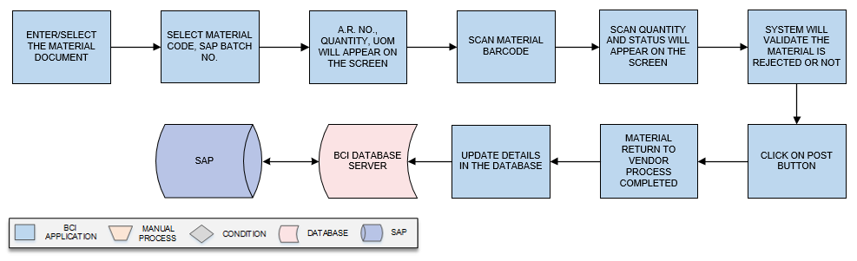
Activities
Module Description | This module will be used return the rejected material to vendor

Pre-Conditions | - Material should be rejected.  - Material document generated in SAP and transferred to MobiVue PMMS application database.

Process Steps | - Enter the Material Document generated in SAP.  - Select Material Code, SAP Batch No. from dropdown.  - A.R. No., Quantity, UOM will appear on the screen.  - User will scan Material Barcode.  - Scan Quantity and Status will appear on the screen.  - System will validate the material is rejected or not.  - Click on Post button to confirm SAP that return to vendor is completed after completing scanning of all material barcodes.  - Material Return to Vendor process completed successfully.  - Details will saved in database.

Post-Conditions | - Dispatch the material containers to vendor.

Validations | - An alert should be displayed in case duplicate/ invalid Material Barcode is selected.  - Only rejected material can be scan.

Destruction
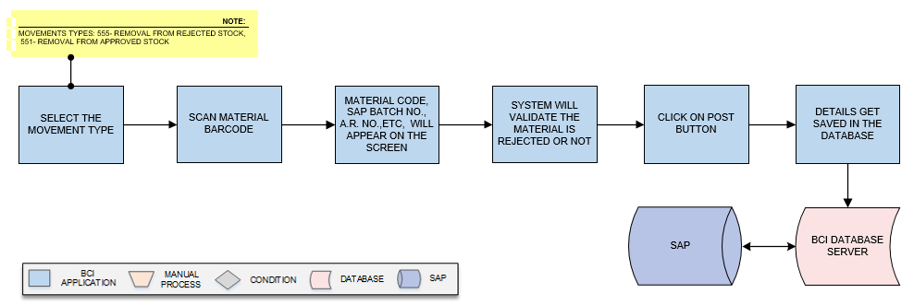
Activities
Module Description | This module will be used destroy the rejected material.

Pre-Conditions | - Material should be rejected.  - Material document generated in SAP and transferred to Pharmision application database..

Process Steps | - Select the movement type (555/551) from the dropdown.  *Movements types: 555- Removal from rejected stock, 551- removal from approved stock.  - User will scan Material Barcode.  - Material Code, SAP Batch No., A.R. No., Container Quantity, UOM will appear on the screen.  - System will validate the material is rejected or not.  - After completing scanning of all material barcodes, user will click on Post button to confirm SAP that Destruction is completed.  - Destruction details saved in database.

Post-Conditions | - Destruction is completed.

Validations | - An alert should be displayed in case duplicate/ invalid Material Barcode is selected.  - Only rejected material can be scan.

Non Functional Requirements
Following are the non-functional requirements of the MobiVue PMMS Application:
- Minimum User ID Length is 3
- Minimum Password Length is 8.
- Maximum tenure of Password is of 90 days.
- Password Complexity- Password must contain 8 characters, one uppercase letter, one lowercase letter and a special character.
- Account will be logged out in following two conditions:
- Account will be logged out if a user is already logged in on other device/ system
- If Login is attempted with invalid Password for 3 times.
- Session Duration can be set as per user practice.
- Role management module available for creation of the role as per the requirement, user can select individual sub-module along with defined authority.

